
30

REPUBLIC OF GHANA

THE COMPOSITE BUDGET

OF THE
GOMOA WEST DISTRICT ASSEMBLY

FOR THE

2024 FISCAL YEAR

OCTOBER, 2023

APPROVAL STATEMENT
The Gomoa West District Assembly at its General Assembly Meeting held on 31 / 10 / 2023 approved the District Composite Budget for the 2024 Fiscal year.

……………………………….. ………………………………
Presiding Member District Coord. Director
Hon. Roger Amoako Mr. Martin Twumasi
Date: 31 / 10 / 2023 Date: 31 / 10 / 2023

Contents
INTRODUCTION 1
STRATEGIC OVERVIEW OF THE ASSEMMBLY 1
NAME OF DISTRICT AND ESTABLISHMENT 1
POPULATION 1
DISTRICT ECONOMY 1
Agriculture 1
Road Network 2
Education 2
Health 2
Sanitation 2
Water 3
Tourism 3
KEY ISSUES/CHALLENGES 3
VISION OF THE DISTRICT ASSEMBLY 4
GOAL OF THE DISTRICT ASSEMBLY 4
MISSION STATEMENT OF THE DISTRICT ASSEMBLY 4
CORE FUNCTIONS OF THE DISTRICT ASSEMBLY 4
THE DISTRICT ADOPTED POLICY OBJECTIVES 4
FINANCIAL PERFORMANCE – REVENUE 6
FINANCIAL PERFORMANCE – REVENUE 7
FINANCIAL PERFORMANCE – EXPENDITURE 8
FINANCIAL PERFORMANCE - EXPENDITURE 9
FINANCIAL PERFORMANCE – EXPENDITURE 10
2023 BUDGET PROGRAMME PERFORMANCE 11
2023 KEY PROJECTS AND PROGRAMMES FROM ALL FUNDING SOURCES 12
NON- FINANCIAL PERFORMANCE BY PROGRAMMES 13
KEY ACHIEVEMENTS (2023) 14
2023 BUDGET PROGRAMME PERFORMANCE 14
GALLERY 15
CONSTRUCTION OF 1 NO. 3-UNIT CLASSROOM BLOCK AT GOMOA OBIRI 15
POLICY OUTCOME INDICATORS AND TARGETS 18
KEY PERFORMANCE INFORMATION FOR BUDGET PROGRAMMES 19
PROGRAMME 1: MANAGEMENT AND ADMINSTRATION 19
PROGRAMME 2: SOCIAL SERVICE DEIVERY 20
PROGRAMME 3: INFRASTRUCTURE DELIVERY AND MANAGEMENT 21
PROGRAMME 4: ECONOMIC DEVELOPMENT 21
PROGRAMME 5: ENVIRONMENTAL MANAGEMENT 22
SANITATION BUDGET PERFORMANCE 23
DONOR PARTNER SUPPORTED PROGRAMMES 23
GOVERNMENT FLAGSHIP PROJECTS AND PROGRAMMES 24
OUTLOOK FOR 2024 25
MMDA ADOPTED POLICY OBJECTIVES FOR 2024 26
POLICY OUTCOME INDICATORS AND TARGETS 27
KEY PERFORMANCE INFORMATION FOR BUDGET PROGRAMMES 30
MANAGEMENT AND ADMINISTRATION 30
SOCIAL SERVICES DELIVERY 31
INFRASTRUCTURE DELIVERY AND MANAGEMENT 32
ECONOMIC DEVELOPMENT 33
ENVIRONMENTAL MANAGEMENT 34
2023-2026 REVENUE PROJECTIONS-IGF ONLY 35
2023-2026 REVENUE PROJECTIONS- ALL REVENUE SOURCES 36
EXPENDITURE BY BUDGET PROGRAMME AND ECONOMIC CLASSIFICATION - ALL FUNDING SOURCES 37
2024 EXPENDITURE BY BUDGET PROGRAMME AND PROJECTS 38
GOVERNMENT FLAGSHIP PROJECTS OR PROGRAMMES FOR 2024 46
2024-2027 EXPENDITURE PROJECTIONS BY ECONOMIC CLASSIFICATION-ALL FUNDING SOURCES 47
SUMMARY OF EXPENDITURE BUDGET BY DEPARTMENT, ECONOMIC CLASSIFICATION AND FUNDING SOURCES - 2024 48
PROJECTS FOR 2024 AND CORRESPONDING COST AND JUSTIFICATION 50
SANITATION BUDGET 62
UNICEF SUPPORT (DP) – CHILD RIGHT, PROTECTION AND PROMOTION 63

List of Tables
Table 1: Revenue Performance - IGF Only 6
Table 4: Expenditure Performance (All Departments) IGF Only 9
Table 5: Expenditure Performance (All Departments) All Funding Sources 10
Table 7: 2022 Key Projects and Programmes from All Funding Sources 12
Table 21: Expenditure by Budget Programme and Economic Classification - All Funding Sources 37
Table 26: KPI - Environment Management 34
Table 29: Government Flagship Projects and Programmes for 2023 46
Table 30: 2023 - 2026 Expenditure Projections by Economic Classification - All Funding Sources 47
Table 31: Summary of Expenditure Budget by Department, Economic Classification and Funding Sources - 2023 48
Table 32: Projects for 2023 and Corresponding Cost and Justification 50
Table 33: Sanitation Budget (Liquid Waste) 62

INTRODUCTION

STRATEGIC OVERVIEW OF THE ASSEMMBLY

NAME OF DISTRICT AND ESTABLISHMENT
Gomoa West District was established by L.I. 1896 with its capital as Apam in July, 2008. It shares boundary to the North East with Agona West and Asikuma Odoben Brakwa; to the South by Gulf of Guinea; East by Gomoa Central District and Efutu; and the west Ekumfi and Ajumako-Enyan-Essiam respectively. It has a total land area of 514.2 Square Kilometres.

POPULATION
The population of the district, by the 2010 Population and Housing Census is 135,189 and with an inter-censual growth rate of 3.2% it is projected to be 197,286 in 2022. The district population is about 6.1% of the regional population. The females constitute 55.3% of the total population of the district against 44.7% for males.

DISTRICT ECONOMY

Agriculture
The food requirement for the year 2022 is projected to be 10,274 tonnes of mostly produced staple food crops, 12,328 tonnes of fruit, 14,383 tonnes of protein and 6,164 kg of vegetables.
To meet this food need, 49.6 percent of households in the District are engaged in agriculture. Out of the agricultural households, 93.0 percent are involved in crop farming, whiles 29.3 percent are into livestock farming rearing, and 1.3 percent are into tree planting whilst as many as about eight thousand (8,000) people are involved in fish farming. It must be understood that these activities are not exclusive, hence one household could be involved in one or more activities and these have been recorded as such.

Road Network
The district has a total road network of 390.25km comprising of 240km un-tarred and 150.25km tarred. 24.67km of Accra – Cape Coast section of N1 highway passes through the District from Bewadze to Gomoa Antseadze and 25.48 km of highway on Apam to Swedru road.

Education
The District has 359 basic schools (218 public and 141 private) and 3 Senior High Schools (SHS). Together, the basic schools have total enrolment of 30,984 with gender parity ratio of 1.19, 1.15 and 1.12 for pre-school, primary and JHS respectively. There 1,479 teachers in the district, out of which 911 are trained and the rest 568 untrained.

Health
The District Health Directorate has six Sub-Districts, these include Apam, Mumford, Osedze, Dago, Onyadze and Gomoa Oguaa providing services with special emphasis on primary health care at all levels. There are Twenty-Seven health institutions in the District made up of one Mission Hospital, five Health Centres, one Reproductive and Child Health Centre, seventeen CHPS zones, two community clinics and one Nutrition Rehabilitation Centre. The district has also one private maternity home. There are 78 communities in the district with 97 outreach points, 105 Trained Traditional Birth Attendants. The total number of health personnel in the district is one hundred and thirty-five (135).

Sanitation
Sanitation is a major challenge across the district about only 35.74% of the total population the access to improved basic sanitation. A total of 480.90 tonnage of refuse is generated per cap/week, only 88.8 tonnage of refuse is collected per week representing 18.47% while 392.10 uncollected representing 81.53%. Fifteen (15) communities have been entered and triggered on community Led Total Sanitation (CLTS) with one (1) potential ODF community (Gomoa Ada)
The GWDA has initiated a special sanitation programme aimed at eliminating open defecation and improving the general environmental conditions in the district especially Apam, Mumford, Ankamu and other surrounding communities.
Sanitation related diseases are among the top ten (10) reported cases at the out-patient department (OPDs) of the health facilities in the district over the years, among them are typhoid fever, diarrhea and malaria.
The District Assembly has embarked on series of massive clean-up exercises evacuation of heaps of refuse and also sanitation. Sensitization campaigns aimed at improving and expanding coverage or use of facilities for safe human excreta disposal.

Water
The estimate annual water demand of the district is estimated to 6.5m m³ per year (17,800 m³ per day). These are partly supplied from two major sources of treated water for household water needs – Ghana Water Company Ltd (GWCL) and Community Water and Sanitation Agency (CWSA). There is evidence to suggest that the populace depend on sachet (0.5l packaged water in plastic bags) mainly for drinking. According to GWCL and CWSA, they serve about 70% of geographical land space, and about additional 25% depend on boreholes. Hence, the District has estimated 95% geographical coverage of potable water.

Tourism
The district is endowed with diverse tourist attractions with the potential of contributing immensely to the local economy. These attractions are mainly cultural and environmental in nature. These include Fort Patience built by the Danes 1872 at Apam, the strange rock at Dago (where a huge rock is said to be carried by a tiny rock), the saltless spring from Ekoku at the coast of Mumford. Other historical objects include the metal walking stick used by the legendary Asebu Amenfi at Gomoamaim and the slave chains used by the colonial merchants at Gomoa Nduem.

KEY ISSUES/CHALLENGES
The key challenges that confront the districts are as follows
- Low food production to meet the demands of the population
- Child trafficking
- Existence of Open Defecation throughout the District
- Poor sanitation especially at Apaa Padoo in Apam
- Frequent attrition and requisite personnel (revenue collectors, teachers, nurses etc)
- Unrealistic/ unscientific valuation of properties for proper billing
- Relatively high poverty rate due to low-income generation activities in the District

VISION OF THE DISTRICT ASSEMBLY
First class local government institution delivering excellent services

GOAL OF THE DISTRICT ASSEMBLY
The goal of the Gomoa West District is to advance equitable socio-economic development through effective Human Resource Development, good governance and private sector empowerment

MISSION STATEMENT OF THE DISTRICT ASSEMBLY
The Gomoa West District exists to facilitate the improvement of the quality of life of the people within the Assembly’s jurisdiction, through equitable provision of service for the total development of the district with the context of good governance.

CORE FUNCTIONS OF THE DISTRICT ASSEMBLY
The core functions of the District are outlined below:
- Exercise political and administrative authority in the District.
- Promote local economic development.
- Provide guidance, give direction to and supervise other administrative authorities in the District as may be prescribed by law.
- Have Deliberative, Legislative and Executive functions.
- Responsible for the overall development in the District.
- Formulate and execute plans, programs and strategies for the overall development of the District.
- In co-operation with the appropriate National and Local Security Agencies, be responsible for the maintenance of security and public safety in the District.
- Initiate programs for the development of basic infrastructure and provide District works (schools, clinics, etc.) and services (sanitation, water, play grounds, etc.) in the District.
- Formulation and approval of plans and composite budget of the District
- Levy and collect taxes, rates, fees, etc. to generate revenue.
- Making of Bye-laws.

THE DISTRICT ADOPTED POLICY OBJECTIVES
- Improve efficiency and effectiveness of road transport infrastructure and services
- Enhance equitable access to, and participation in quality education at all levels
- Ensure accessible and quality Universal Health Coverage (UHC) for all
- Improve post-harvest management
- Enhance access to improved and sustainable environmental sanitation services
- Enhance climate change resilience
- Eradicate poverty and address vulnerability to poverty in all forms and dimensions

FINANCIAL PERFORMANCE – REVENUE
Table 1: Revenue Performance - IGF Only
REVENUE PERFORMANCE – IGF ONLY
ITEM | 2021 |  | 2022 |  | 2023
 | BUDGET | ACTUAL | BUDGET | ACTUAL | BUDGET | ACTUAL | PERF.
Property Rate | 120,000.00 | 109,359.00 | 144,000.00 | 99,858.00 | 50,000.00 | 20,480.00 | 40.96
Other Rates | 5,000.00 | 0.00 | 5,000.00 | 0.00 | 0.00 | 0.00 | 0.00
Fees | 171,084.67 | 173,683.46 | 188,000.00 | 203,299.54 | 114,500.00 | 103,975.43 | 90.81
Fines | 2,500.00 | 2,082.86 | 10,000.00 | 10,724.57 | 10,000.00 | 9,415.70 | 94.16
Licenses | 284,553.00 | 149,173.20 | 189,000.00 | 185,053.38 | 242,800.00 | 146,946.00 | 60.52
Land | 154,000.00 | 159,633.38 | 240,000.00 | 262,932.57 | 290,000.00 | 208,240.50 | 71.81
Rent | 65,107.04 | 26,058.00 | 24,000.00 | 21,523.00 | 64,250.00 | 36,370.00 | 56.62
Investment | 0.00 | 42,800.00 | 50,000.00 | 24,850.00 | 0.00 | 6,400.00 | 0.00
Miscellaneous | 900.00 | 1,490.00 | 0.00 | 1,200.00 | 0.00 | 800.00 | 0.00
TOTAL | 803,144.71 | 664,279.90 | 850,000.00 | 809,441.06 | 771,550.00 | 532,627.63 | 69.03

FINANCIAL PERFORMANCE – REVENUE
Table 2: Revenue Performance - All Revenue Sources
REVENUE PERFORMANCE – ALL REVENUE SOURCES
ITEM | 2021 |  | 2022 |  | 2023
 | BUDGET | ACTUAL | BUDGET | ACTUAL | BUDGET | ACTUAL AS AT AUGUST | % PER. AS AT AUG
IGF | 803,144.71 | 664,279.90 | 850,000.00 | 809,441.06 | 771,550.00 | 532,627.63 | 69.03
COMPENSATION TRANSFER | 3,816,923.40 | 3,638,477.26 | 4,050,000.00 | 4,912,540.15 | 4,050,000.00 | 4,556,763.43 | 112.51
GOODS AND SERVICE TRANSFER | 94,236.00 | 65,937.51 | 116,783.00 | 36,114.35 | 56,000.00 | 24,475.25 | 43.71
ASSET TRANSFER | - | - | 0.00 | 0.00 | 0.00 | 0.00 | 0.00
DACF | 4,570,970.40 | 1,243,889.72 | 4,717,102.29 | 2,540,773.33 | 4,717,102.29 | 1,033,319.30 | 21.91
DACF- RFG | 2,313,149.00 | 1,716,110.00 | 1,195,422.00 | 1,154,505.55 | 1,718,664.35 | 0.00 | 0.00
MAG | 128,838.00 | 104,030.12 | 81,784.00 | 81,784.46 | 118,197.24 | 118,197.24 | 100.00
SECONDARY CITIES | - | - | - | - | - | - | -
OTHER TRANSFER (UNICEF) | - | - | 30,000.00 | 15,000.00 | 60,000.00 | 15,000.00 | 25.00
TOTAL | 11,727,261.51 | 7,432,724.51 | 11,041,091.29 | 9,550,158.90 | 11,491,513.89 | 6,280,382.85 | 54.65

FINANCIAL PERFORMANCE – EXPENDITURE
Table 3: Expenditure Performance (All Departments) GOG Only
EXPENDITURE PERFORMANCE (ALL DEPARTMENTS) GOG ONLY

EXPENDITURE | 2021 |  | 2022 |  | 2023
 | BUDGET | ACTUAL | BUDGET | ACTUAL | BUDGET | ACTUAL AS AT AUGUST | % PER. AS AT AUG
Compensation | 3,816,923.40 | 3,638,477.26 | 4,050,000.00 | 4,912,540.15 | 4,050,000.00 | 4,556,763.43 | 112.51
Goods & Services | 94,236.00 | 65,937.51 | 81,784.00 | 36,114.35 | 56,000.00 | 24,475.25 | 43.71
Assets | - | - | - | - | - | - | -
Total | 3,911,159.40 | 3,704,414.77 | 4,131,784.00 | 4,948,654.50 | 4,106,000.00 | 4,581,238.68 | 111.57

FINANCIAL PERFORMANCE - EXPENDITURE
Table 2: Expenditure Performance (All Departments) IGF Only
EXPENDITURE PERFORMANCE (ALL DEPARTMENTS) IGF ONLY
EXPENDITURE ITEM | 2021 |  | 2022 |  | 2023 |  | % PER AS AT AUG, 2023
 | BUDGET | ACTUAL | BUDGET | ACTUAL | BUDGET | ACTUAL As At AUGUST, 2021
Compensation | 131,213.64 | 127,191.60 | 95,589.23 | 83,341.08 | 105,131.88 | 64,607.20 | 61.45
Goods & Services | 510,793.18 | 537,088.30 | 584,410.77 | 726,099.98 | 512,108.12 | 437,674.83 | 85.74
Assets | 161,137.89 | 0.00 | 170,000.00 | 0.00 | 154,310.00 | 24,176.38 | 15.67
Total | 803,144.71 | 664,279.90 | 850,000.00 | 809,441.06 | 771,550.00 | 526,458.41 | 68.23

FINANCIAL PERFORMANCE – EXPENDITURE
Table 3: Expenditure Performance (All Departments) All Funding Sources
EXPENDITURE PERFORMANCE (ALL DEPARTMENTS) ALL FUNDING SOURCES

EXPENDITURE | 2021 |  | 2022 |  | 2023
 | BUDGET | ACTUAL | BUDGET | ACTUAL | BUDGET | ACTUAL AS AT AUGUST | % PER. AS AT AUG
COMPENSATION | 3,816,923.40 | 3,638,477.26 | 4,145,589.23 | 4,992,663.95 | 4,155,131.88 | 4,624,370.63 | 111.29
GOODS AND SERVICES | 4,107,976.69 | 1,669,390.66 | 4,024,975.67 | 762,214.33 | 4,458,054.29 | 1,666,580.55 | 37.39
ASSET | 3,802,361.42 | 1,879,370.26 | 2,870,526.39 | 1,007,461.50 | 2,878,327.72 | 171,395.79 | 5.95
TOTAL | 11,727,261.51 | 7,187,238.18 | 11,041,091.29 | 6,762,339.78 | 11,491,513.89 | 6,462,346.97 | 56.24

2023 BUDGET PROGRAMME PERFORMANCE
Table 6: 2023 Budget Programme Performance
BUDGET PROGRAMME | BUDGET | ACTUAL AS AT AUG 2023
MANAGEMENT AND ADMINISTRATION | 3,915,534.56 | 2,492,582.27
SOCIAL SERVICES DELIVERY | 1,478,305.42 | 2,101,612.15
INFRASTUCTURE DELIVERY AND MANAGEMENT | 5,097,887.34 | 1,020,202.48
ECONOMIC DEVELOPMENT | 980,502.58 | 841,055.19
ENVIRONMENTAL MANAGEMENT | 19,282.50 | 6,894.88
TOTAL | 11,491,513.89 | 6,462,346,97

2023 KEY PROJECTS AND PROGRAMMES FROM ALL FUNDING SOURCES
Table 74: 2023 Key Projects and Programmes from All Funding Sources
NO | NAME OF PROJECT/ PROGRAMME | AMOUNT BUDGETED (GH¢) | ACTUAL PAYMENT AS AT AUGUST, 2023 | OUTSTANDING PAYMENT
1 | Construction of 1No. -6 Unit Teachers Quarters at Gomoa Mankoadze | 795,768.60 | 335,045.25 | 460,723.35
2 | Construction of 1no. 3unit classroom block at Obiri | 219,685.26 | 138,919.44 | 80,765.82
3 | Construction of 1no. 3unit classroom block at Appiakrom Debiso | 518,945.10 | 201,993.44 | 316,951.66

NON- FINANCIAL PERFORMANCE BY PROGRAMMES

KEY ACHIEVEMENTS (2023)
- Construction of 1No. 6Unit Teachers’ Quarters at Mankoadze
- Construction of 1no. 3unit classroom block at Gomoa Obiri
- Construction of 1no. 3unit classroom block at Appiakrom Debiso

2023 BUDGET PROGRAMME PERFORMANCE
Table 8: 2023 Budget Programme Performance
S/N | ACHIEVEMENTS | LOCATION | STATUS | FUNDING | AMOUNT GH₵
1 | Construction of 1No 3Unit Teachers’ Quarters | Mankoadze |  | DACF-RFG | 795,768.60
2 | Construction of 1no. 3unit classroom block | Gomoa Obiri | Completed | DACF | 219,685.26
3 | Construction of 1no. 3unit classroom block | Appiakrom Debiso |  | DACF | 518,945.10

GALLERY

CONSTRUCTION OF 1 NO. 3-UNIT CLASSROOM BLOCK AT GOMOA OBIRI
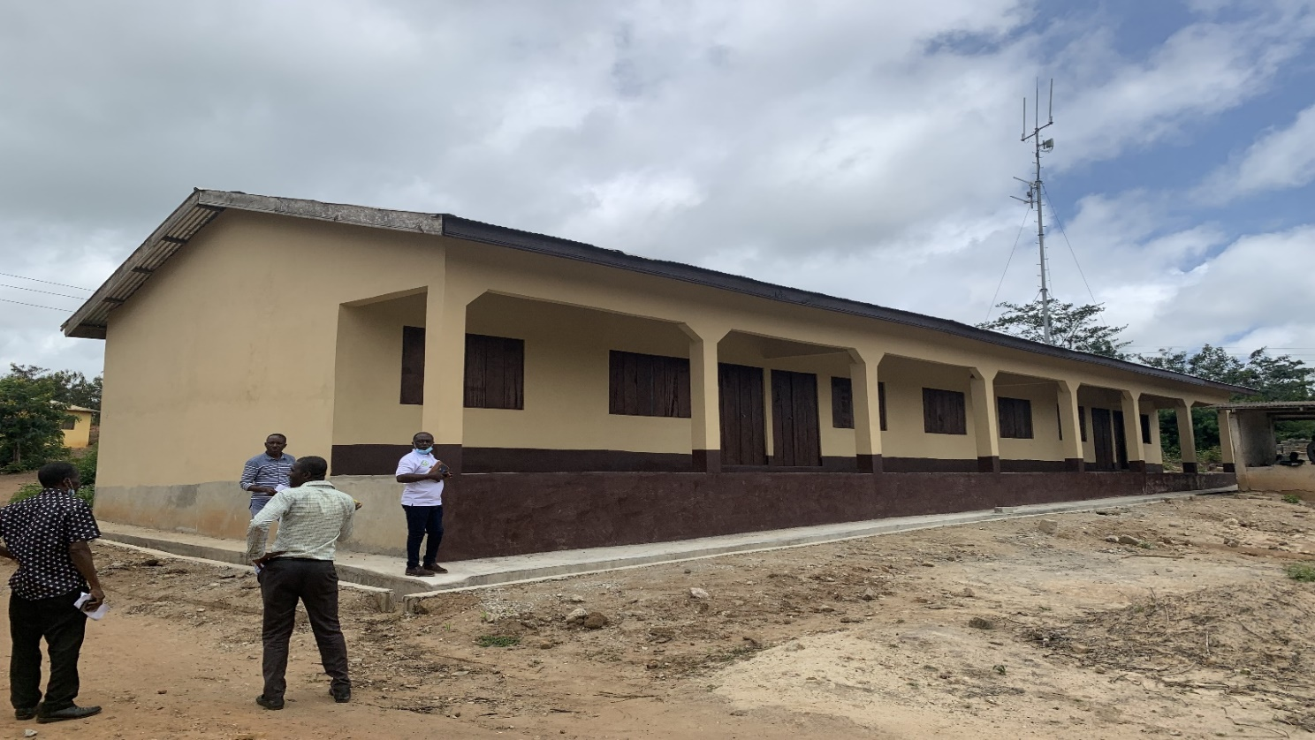
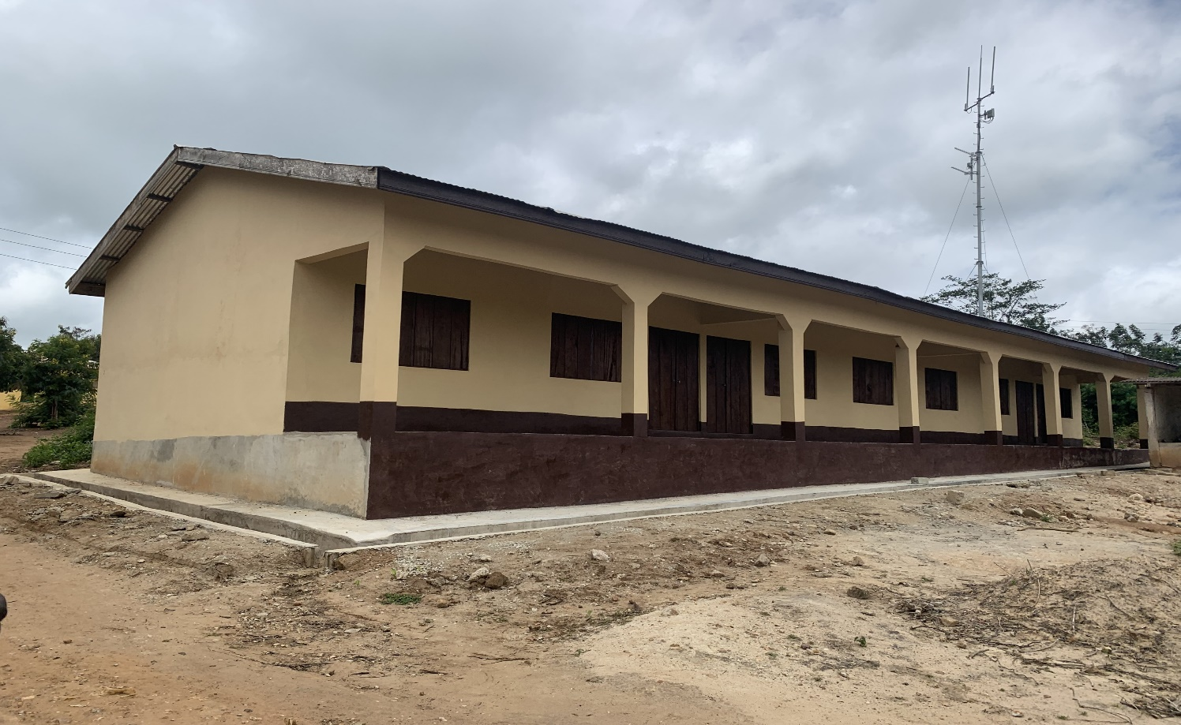

DISTRIBUTION OF TREE SEEDLINGS (1,612) TO FARMERS
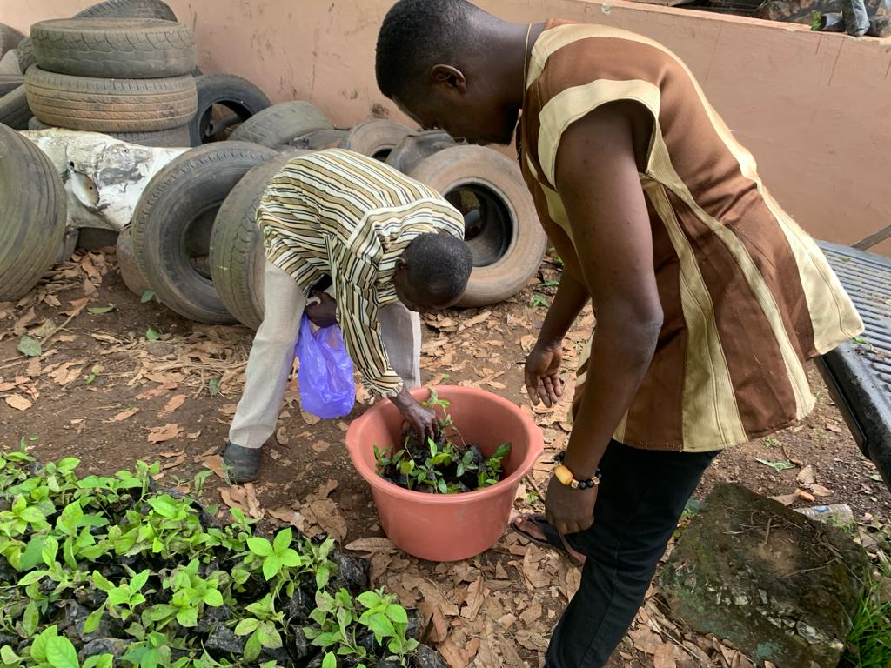
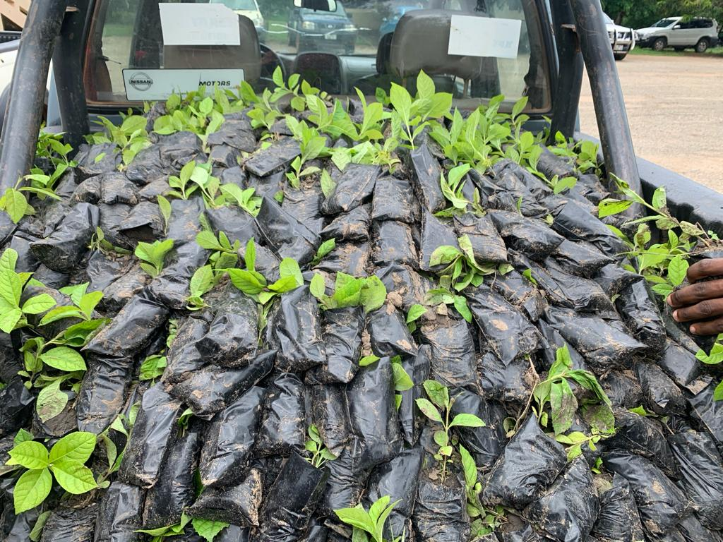

CONSTRUCTION OF 1NO 6UNIT TEACHERS QUARTERS AT GOMOA MANKOADZE
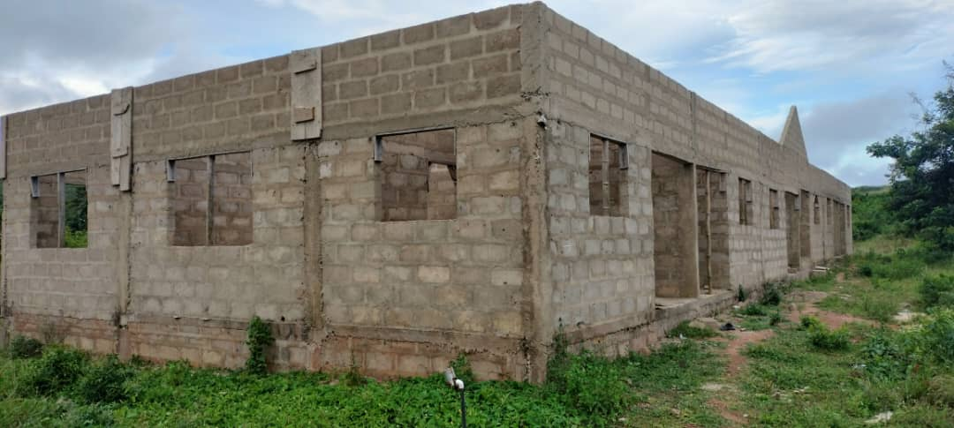

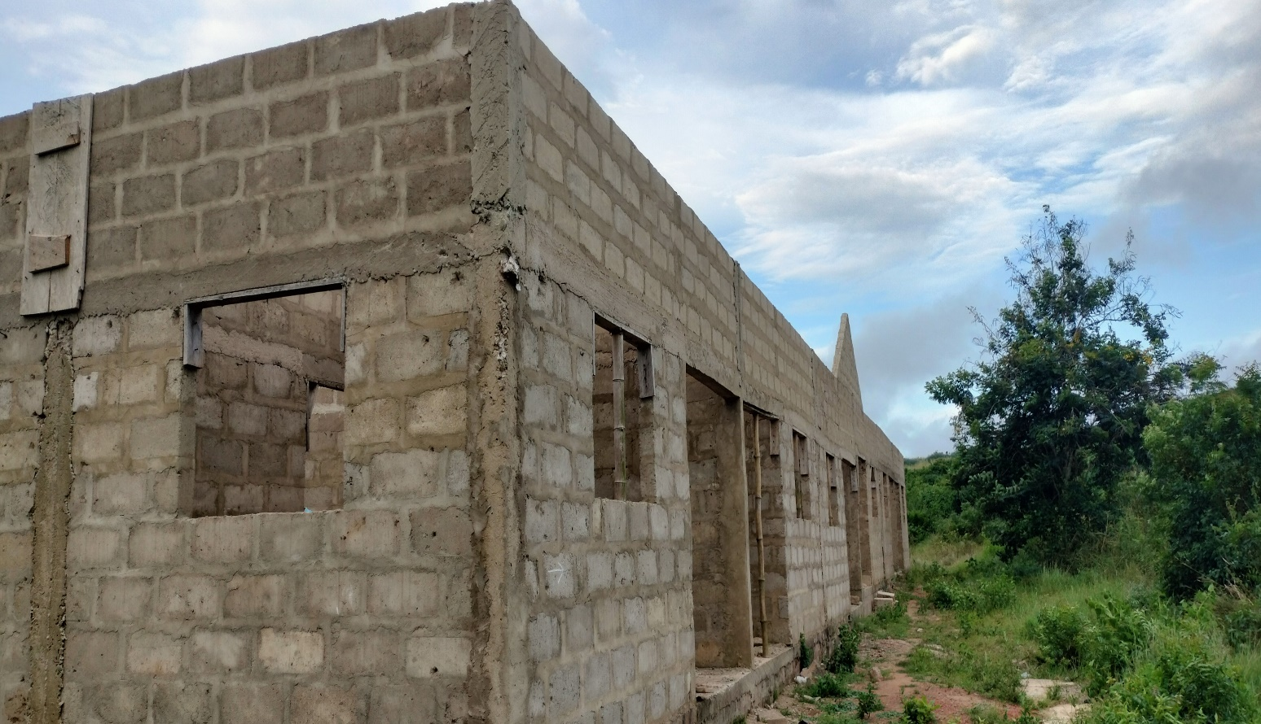

POLICY OUTCOME INDICATORS AND TARGETS
Table 9: Policy Outcome Indicators and Targets
OUTCOME INDICATOR DESCRIPTION | UNIT OF MEASUREMENT | BASELINE (2021) |  | PREVIOUS YEAR’S PERFORMANCE 2022 |  | CURRENT YEAR’S ACTUAL PERFORMANCE 2023
OUTCOME INDICATOR DESCRIPTION | UNIT OF MEASUREMENT | TARGET | ACTUAL | TARGET | ACTUAL | TARGET | ACTUAL AS AT AUG
Internally generated revenue improved | Actual IGF mobilized | 803,144.71 | 664,279.90 | 850,000.00 | 809,441.06 | 771,550.00 | 532,627.63
Performance contract indicators achieved | Score of DPAT assessment | 100% | 99% | 100% | 99% | 100% | -
Increased citizenship engagement in deepening democracy | Number of community engagements held | 78 | 69 | 78 | 72 | 78 | 51
Increased citizenship engagement in deepening democracy | Number of town hall meetings held | 2 | 2 | 2 | 2 | 2 | 2
Improved teaching and learning | Number of teacher’s quarters built | 2 | 1 | 1 | 1 | 1 | 0
Improved access to health delivery | Number of CHPS built | 2 | 0 | 3 | 2 | 1 | 0
Reduced human trafficked | Number of humans trafficked | 3 | 6 | 3 | 53 | 20 | 3
Screened food vendors in the district | Number of food vendors screened | 1,500 | 1,429 | 1,500 | 1,441 | 1,500 | 1,87
Roads reshaped in the district | Kilometers of roads reshaped | 17km | 17km | 38.60 | 38.60 | 43.58 | 28.45
Agriculture home and farm demonstration | Number of demonstration farms done | 24 | 5 | 10 | 3 | 12 | 15
Community farm-based training held | Number of females trained | 50 | 125 | 5,000 | 5,993
Community farm-based training held | Number of males trained | 25 | 123 | 5,000 | 6,512

KEY PERFORMANCE INFORMATION FOR BUDGET PROGRAMMES

PROGRAMME 1: MANAGEMENT AND ADMINSTRATION
Table 10: KPI – Programme 1
Key/Main Outputs | Output Indicator | Past Years
Key/Main Outputs | Output Indicator | 2022  TARGET | 2022  ACTUAL | 2023  TARGET | 2020Actual22  2023  ACTUAL AS AT AUG
Plans (AAP, RIAP, etc. and Composite Budgets) prepared and reviewed | Annual Action Plan prepared by | 30TH June | 30TH June | 30TH June | 30TH June
 | District Composite Budget prepared and approved by | 31st Oct. | 29th October | 29th October | 29th October
 | No. of Community Action Plans prepared | 7 | 7 | 7 | 7
 | No. of Community Action Plans prepared by sub structures | 7 | 7 | 7 | 7
Community Engagement held | Number of Communities visited | 78 | 72 | 78 | 68
Internally generated revenue mobilized | Amount mobilized | 850,000.00 | 809,441.06 | 771,550.00 | 532,627.63

PROGRAMME 2: SOCIAL SERVICE DEIVERY
Table 11: KPI - Programme 2
Key/Main Outputs | Output Indicator | Past Years
Key/Main Outputs | Output Indicator | 2022  TARGET | 2022  ACTUAL | 2023  TARGET | 2020Actual22  2023 ACTUAL AS AT AUG
Educational Facilities Constructed | Number of Teachers Quarters Constructed | 1 | 1 | 1 | 1
Health Facilities Constructed | Number of CHPS Constructed | 3 | 2 | 1 | 0
CLTS Promoted | Number of Communities declared ODF | 2 | 0 | 2 | 0

PROGRAMME 3: INFRASTRUCTURE DELIVERY AND MANAGEMENT
Table 12: KPI - Programme 3
Key/Main Outputs | Output Indicator | Past Years
Key/Main Outputs | Output Indicator | 2022  TARGET | 2022  ACTUAL | 2023  TARGET | 2020Actual22  2023  ACTUAL AS AT AUG
Child protection cases | Count of children reached by social services | 100 | 176 | 300 | 1,412
Provision for Effective and Efficient Transport System | Number of Kilometers of Roads Reshaped | 38.60km | 38.60km | 43.58km | 28.45km
Building permit assessment | Number of building permit issued | 120 | 145 | 150 | 88

PROGRAMME 4: ECONOMIC DEVELOPMENT
Table13: KPI - Programme 4
Key/Main Outputs | Output Indicator | Past Years
Key/Main Outputs | Output Indicator | 2022  TARGET | 2022  ACTUAL | 2023  TARGET | 2020Actual22  2023  ACTUAL AS AT AUG
Ghana jobs and skills projects (YOU START) implemented | Count of unemployed graduates trained | 100 | 100 | 200 | 197
Agricultural farm and home demonstrations Conducted | Number of Demonstration Farms done | 24 | 3 | 20 | 20

PROGRAMME 5: ENVIRONMENTAL MANAGEMENT
Table14: KPI - Programme 5
Key/Main Outputs | Output Indicator | Past Years
Key/Main Outputs | Output Indicator | 2022  TARGET | 2022  ACTUAL | 2023  TARGET | 2020Actual22  2023 ACTUAL AS AT AUG
Public education and disaster risk reduction announcement made | Count of announcement made | 24 | 22 | 30 | 8
Flood mitigation measure undertaken | Number of major drains and motorways dredged | 4 | 2 | 4 | 4
Relief administration to disaster victims | Number of victims supported with relief items | 800 | 496 | 1000 | 0

SANITATION BUDGET PERFORMANCE
Table15: Sanitation Budget Performance (Liquid Waste)
LIQUID WASTE

NO | NAME OF ACTIVITY/ PROJECT | BUDGET | ACTUAL AS AT AUGUST, 2023
1 | Provision for liquid waste management (Fumigation) | 150,937.50 | 75,468.76
2 | Monitoring of Community Led Total Sanitation (CLTS) | 3,800.00 | 0.00

Table16: Sanitation Budget Performance (Solid Waste)
SOLID WASTE

NO | NAME OF ACTIVITY/ PROJECT | BUDGET | ACTUAL AS AT AUGUST, 2023
1 | Provision of solid waste management (SIP) | 159,561.15 | 79,780.58
2 | Environmental sanitation management and Clean Up Exercise | 90,000.00 | 37,486
3 | Desilting of Gutters | 40,000.00 | 0.00

DONOR PARTNER SUPPORTED PROGRAMMES
Table 17: Donor Partner Supported Programme
NO | NAME OF ACTIVITY/ PROJECT | BUDGET | ACTUAL AS AT AUGUST, 2023
1 | Modernizing Agriculture in Ghana (MAG) | 81,784.00 | 81,784.00
2
3
4

GOVERNMENT FLAGSHIP PROJECTS AND PROGRAMMES
Table18: Government Flagship Projects and Programme
NO | NAME OF ACTIVITY/ PROJECT | BUDGET | ACTUAL AS AT AUGUST, 2023
1 | Nursing and distribution of coconut seedlings for farmers (PERD) | 70,000.00 | 0.00
2 | Distribution of maize seeds and fertilizer to farmers within the district (PFJ) | 10,000.00 | 4,890.00
3 | Monitoring of all data on all government flagship projects and programmes (DCACT) | 5,000.00 | 2,369.00

OUTLOOK FOR 2024

MMDA ADOPTED POLICY OBJECTIVES FOR 2024
Table19: MMDA Adopted Policy Objectives for 2024
FOCUS AREA | POLICY OBJECTIVE | BUDGET ALLOCATION
Governance, Corruption and Public Account. | Ensure full political, administrative and fiscal decentralization | 4,595,528.26
Transportation: Air, Rail, Water and Road | Improve efficiency and effectiveness of road transport infrastructure and services | 1,830,733.83
Education and training | Enhance equitable access to, and participation in quality education at all levels | 2,284,202.06
Health and health services | Ensure accessible, and quality Universal Health Coverage (UHC) for all | 1,200,981.06
Reducing poverty and inequality | Eradicate poverty and address vulnerability to poverty in all forms and dimensions | 219,355.57
Reducing poverty and inequality | Reduce income disparities within and across socio-economic groups and geographical areas | 501,623.81
Tourism and creative industry development | Diversify and expand the tourism industry for economic development | 57,382.50
Agriculture and rural development | Improve post-harvest management | 1,082,249.85
Water and environmental sanitation | Enhance access to improved and sustainable environmental sanitation services | 1,133,743.99
Climate variability and change | Enhance climate change resilience | 19,000.00
TOTAL |  | 12,924,800.95

POLICY OUTCOME INDICATORS AND TARGETS
Table20: Policy Outcome Indicators and Targets
Outcome Indicator Description | Unit of Measurement | BASELINE (2022) |  | CURRENT YEAR (2023) |  | BUDGET YEAR (2024) | INDICA  TIVE YEAR (2025) | INDICA  TIVE YEAR (2026) | INDICA  TIVE YEAR (2027  )
Outcome Indicator Description | Unit of Measurement | TARGET | ACTUAL | TARGET | AS AT AUG | TARGET | TARGET | TARGET | TARGET
Democratic governance deepened | Number of town hall meetings organized | 2 | 2 | 2 | 1 | 2 | 2 | 2 | 2
Democratic governance deepened | Number of community engagement held | 78 | 69 | 78 | 42 | 78 | 78 | 78 | 78
Transparence and public accountability deepened | Number of area council notice board’s audit reports were pasted | 7 | 7 | 7 | 2 | 7 | 7 | 7 | 7
Transparence and public accountability deepened | Number of times PFM Act was used to give information to the public | 4 | 4 | 4 | 2 | 4 | 4 | 4 | 4
Equitable access to and participation in quality education enhanced | Number of teacher’s quarters built | 2 | 2 | 1 | 0 | 1 | 1 | 1 | 1
 | Number of desks supplied | 1,800 |  | 1,700 | 1,142 | 0 | 2,000 | 2,000 | 2,000
Healthcare management system strengthened | Number of CHPS built | 2 | 0 | 2 | 1 | 2 | 2 | 2 | 2
Healthcare management system strengthened | Number of mosquito nets distributed | 40,000 | 46,487 | 50,000 | 0 | 50,000 | 50,000 | 50,000 | 50,000
Healthcare management system strengthened | Nurse population ratio | 1:400 | 1:368 | 1:380 | 1:350 | 1:320 | 1:300 | 1:280 | 1:250
Healthcare management system strengthened | Doctor population ratio | 1:12,500 | 1:12,951 | 1:10,000 | 1:11,598 | 1:11,000 | 1:10,500 | 1:0,000 | 1:9,500
Healthcare management system strengthened | Count of midwifery to women fertility population ratio | 1:750 | 1:555 | 1:500 | 1:500 | 1:450 | 1:400 | 1:350 | 1:300
Child protection and family welfare system effectively ensured | Number of children rescued from trafficking | 20 | 4 | 20 | 2 | 10 | 10 | 8 | 6
 | Count of communities visited for sensitization | 55 | 45 | 55 | 28 | 60 | 65 | 70 | 75
 | Count of cases recorded | 30 | 19 | 30 | 14 | 40 | 50 | 50 | 50
Proper maintenance culture promoted | Number of official residential flats renovated | 5 | 1 | 5 | 2 | 5 | 5 | 5 | 5
Proper maintenance culture promoted | Number of office blocks renovated | 2 | 0 | 2 | 1 | 2 | 2 | 2 | 2
Develop effective land administration and management system | Number of communities ground thruthed | 2 | 0 | 2 | 0 | 2 | 2 | 2 | 2
Business environment enhanced | Number of business training organized for SMEs | 150 | 94 | 150 | 90 | 150 | 150 | 150 | 150
Business environment enhanced | Number of persons trained under business financial literacy | 500 | 105 | 500 | 90 | 500 | 500 | 500 | 500
Food and nutrition security ensured | Number of demonstration farms organized | 10 | 3 | 10 | 2 | 5 | 5 | 5 | 5
Food and nutrition security ensured | Number of communities local food consumption promoted | 5 | 2 | 5 | 3 | 5 | 7 | 9 | 11
Food and nutrition security ensured | Number of FBO’s strengthened | 20 | 17 | 30 | 6 | 20 | 20 | 20 | 20

KEY PERFORMANCE INFORMATION FOR BUDGET PROGRAMMES

MANAGEMENT AND ADMINISTRATION
Table22: KPI - Management and Administration
KEY/MAIN OUTPUTS | OUTPUT INDICATOR | PAST YEARS |  |  |  | PROJECTIONS
KEY/MAIN OUTPUTS | OUTPUT INDICATOR | 2021TARGET | 2021  ACTUAL | 2022 TARGET | 2022 ACTUAL AS AT AUG | BUDGET YEAR | INDICATIVE YEAR | INDICATIVE YEAR | INDICATIVE YEAR
 |  |  |  |  |  | 2023 | 2024 | 2025 | 2026
Community engagement held as a way to deepen democracy | Number of communities engaged | 78 | 55 | 78 | 42 | 78 | 78 | 78 | 78
District plans prepared and reviewed (AAP, Budget, Procurement Plan) | Number of times AAP was reviewed | 1 | 1 | 1 | 1 | 1 | 1 | 1 | 1
 | Number of times budget was reviewed | 1 | 1 | 1 | 1 | 1 | 1 | 1 | 1
 | Number of times Procurement plan was reviewed | 4 | 4 | 4 | 4 | 4 | 4 | 4 | 4
District data for revenue mobilization updated | Number of communities data updated | 12 | 6 | 12 | 0 | 12 | 12 | 12 | 12

SOCIAL SERVICES DELIVERY
Table23: KPI - Social Services
KEY/MAIN OUTPUTS | OUTPUT INDICATOR | PAST YEARS |  |  |  | PROJECTIONS
KEY/MAIN OUTPUTS | OUTPUT INDICATOR | 2022  TARGET | 2022  ACTUAL | 2023 TARGET | 2023 ACTUAL AS AT AUG | BUDGET YEAR | INDICATIVE YEAR | INDICATIVE YEAR | INDICATIVE YEAR
 |  |  |  |  |  | 2024 | 2025 | 2026 | 2027
Schools Supervised and Inspected | Number of Schools supervised and Inspected | 84 | 84 | 84 | 84 | 84 | 84 | 84 | 84
Mock Examination Conducted | Number of Pupils benefited | 2,711 | 2,711 | 2,753 | 2,753 | 2,760 | 2,765 | 2,770 | 2,780
Enrollment Increased | Gross Enrollment Rate of JHS Increased | 83% | 71% | 71% | 71% | 83% | 100% | 100% | 100%
Food vendors screened | Count of food vendors screened | 1,500 | 1,441 | 1,500 | 1,875 | 2,000 | 2,500 | 2,700 | 2,800
Conducted continuous distribution of LLIN various facilities | Count of LLIN distributed to pregnant women reached | 1,557 | 1,472 | 1,977 | - | 2,066 | 2,142 | 2,500 | 2,858

INFRASTRUCTURE DELIVERY AND MANAGEMENT
Table24: KPI - Infrastructure Delivery and Management
KEY/MAIN OUTPUTS | OUTPUT INDICATOR | PAST YEARS |  |  |  | PROJECTIONS
KEY/MAIN OUTPUTS | OUTPUT INDICATOR | 2022 TARGET | 2022  ACTUAL | 2023 TARGET | 2023 ACTUAL AS AT AUG | BUDGET YEAR | INDICATIVE YEAR | INDICATIVE YEAR | INDICATIVE YEAR
 |  |  |  |  |  | 2024 | 2025 | 2026 | 2027
Effective and efficient transport system provided (Reshaping) | No. of Kilometres of roads reshaped | 38.60km | 38.60km | 43.58km | 28.45km | 78.50km | 46.00km | 56.78km | 70.00km
Effective and efficient development control activities held | Count of days the team went out for inspections | 96 | 96 | 96 | 68 | 100 | 120 | 120 | 120
Permits Approved | Count of Permits Approved | 120 | 145 | 150 | 88 | 160 | 180 | 190 | 200

ECONOMIC DEVELOPMENT
Table25: KPI - Economic Development
KEY/MAIN OUTPUTS | OUTPUT INDICATOR | PAST YEARS |  |  |  | PROJECTIONS
KEY/MAIN OUTPUTS | OUTPUT INDICATOR | 2022 TARGET | 2022  ACTUAL | 2023 TARGET | 2023 ACTUAL AS AT AUG | BUDGET YEAR | INDICATIVE YEAR | INDICATIVE YEAR | INDICATIVE YEAR
 |  |  |  |  |  | 2024 | 2025 | 2026 | 2027
Business counseling and monitoring trainings held | Number of business benefitted | 50 | 20 | 50 | 23 | 50 | 50 | 50 | 50
CBT in Baking Confectionary | Count of People Benefited | 20 | 18 | 20 | 20 | 25 | 30 | 30 | 35
Demonstrations Farms Organized | Number of Demonstration held | 40 | 30 | 40 | 15 | 6 | 8 | 12 | 15

ENVIRONMENTAL MANAGEMENT
Table 265: KPI - Environment Management
KEY / MAIN OUTPUTS | OUTPUT INDICATOR | PAST YEARS |  |  |  | PROJECTIONS
KEY / MAIN OUTPUTS | OUTPUT INDICATOR | 2022 TARGET | 2022  ACTUAL | 2023 TARGET | 2023 ACTUAL AS AT AUG | BUDGET YEAR | INDICATIVE YEAR | INDICATIVE YEAR | INDICATIVE YEAR
 |  |  |  |  |  | 2024 | 2025 | 2026 | 2027
Public education campaigns on disaster risk reduction organized | Number of times education organized | 24 | 22 | 30 | 8 | 30 | 33 | 36 | 39
Flood mitigation measure undertaken | Number of major drains and motorways dredged | 4 | 2 | 4 | 4 | 6 | 8 | 8 | 8
Climate Change Intervention Publicity and Sensitization Organized | Count of Publicity and Sensitizations Organized | 4 | 2 | 4 | 1 | 4 | 4 | 4 | 4

2023-2026 REVENUE PROJECTIONS-IGF ONLY
Table28: 2023 - 2026 Revenue Projections - IGF Only
ITEM | 2023 |  | 2024 | 2025 | 2026 | 2027
 | BUDGET | ACTUAL as at August | PROJECTION | PROJECTION | PROJECTION | PROJECTION
PROPERTY RATE | 50,000.00 | 20,480.00 | 144,000.00 | 140,000.00 | 152,000.00 | 160,000.00
OTHER RATE | 0.00 | 0.00 | 5,000.00 | 8,000.00 | 10,000.00 | 12,000.00
FEES | 114,500.00 | 103,975.43 | 134,500.00 | 125,000.00 | 140,000.00 | 150,000.00
FINES | 10,000.00 | 9,415.70 | 30,000.00 | 28,000.00 | 37,000.00 | 45,000.00
LICENCE | 242,800.00 | 146,946.00 | 256,224.44 | 260,000.00 | 273,000.00 | 280,000.00
LAND | 290,000.00 | 208,240.50 | 330,000.00 | 350,000.00 | 330,000.00 | 350,000.00
RENT | 34,250.00 | 36,370.00 | 75,200.00 | 80,000.00 | 84,000.00 | 90,000.00
INVESTMENT | 30,000.00 | 6,400.00 | 0.00 | 0.00 | 0.00 | 0.00
MISCELLANEOUS | 0.00 | 800.00 | 0.00 | 0.00 | 0.00 | 0.00
TOTAL | 771,550.00 | 532,627.63 | 971,878.44 | 991,000.00 | 1,026,000.00 | 1,087,000.00

2023-2026 REVENUE PROJECTIONS- ALL REVENUE SOURCES
Table28: 2023 - 2026 Revenue Projections – All Revenue Sources
ITEM | 2023 |  | 2024 | 2025 | 2026 | 2027
ITEM | BUDGET | ACTUAL AS AT AUG | PROJECTIONS | PROJECTIONS | PROJECTIONS | PROJECTIONS
IGF | 771,550.00 | 532,627.63 | 971,878.44 | 991,000.00 | 1,026,000.00 | 1,087,000.00
COMPENSATION TRANSFER | 4,050,000.00 | 4,556,763.43 | 5,109,601.25 | 5,250,000.00 | 5,770,000.00 | 6,150,000.00
GOODS AND SERVICE TRANSFER | 56,000.00 | 24,475.25 | 93,500.00 | 110,000.00 | 120,000.00 | 130,000.00
ASSET TRANSFER | 0.00 | 0.00 | 0.00 | 0.00 | 0.00 | 0.00
DACF | 4,717,102.29 | 1,033,319.30 | 4,717,102.29 | 6,000,000.00 | 6,314,273.00 | 6,322,283.00
DACF- RFG | 1,718,664.35 | 0.00 | 2,002,738.78 | 1,566,789.00 | 1,600,456.00 | 1,786,224.00
MAG | 118,197.24 | 118,197.24 | 0.00 | 0.00 | 0.00 | 0.00
SECONDARY CITIES | - | - | - | - | - | -
OTHER TRANSFER (UNICEF) | 60,000.00 | 15,000.00 | 30,000.00 | 60,000.00 | 60,000.00 | 60,000.00
TOTAL | 11,491,513.89 | 6,280,382.85 | 12,924,820.76 | 13,977,789.00 | 14,890,729.00 | 15,535,507.00

EXPENDITURE BY BUDGET PROGRAMME AND ECONOMIC CLASSIFICATION - ALL FUNDING SOURCES
Table 216: Expenditure by Budget Programme and Economic Classification - All Funding Sources
BUDGET PROGRAMME | COMPENSATION OF EMPLOYEES | AMOUNT GH₵
BUDGET PROGRAMME | COMPENSATION OF EMPLOYEES | GOODS AND SERVICES | CAPITAL EXPENDITURE | TOTAL
MANAGEMENT AND ADMINISTRATION | 3,097,859.40 | 1,479,688.74 | 18,000.00 | 4,595,548.14
SOCIAL SERVICES DELIVERY | 1,093,775.23 | 890,786.18 | 3,355,345.08 | 5,339,906.49
INFRASTRUCTURE DELIVERY AND MANAGEMENT | 445,385.52 | 1,241,580.71 | 143,767.80 | 1,830,733.83
ECONOMIC DEVELOPMENT | 593,913.54 | 545,718.81 | 0.00 | 1,139,632.35
ENVIRONMENTAL MANAGEMENT | 0.00 | 19,000.00 | 0.00 | 19,000.00
TOTAL | 5,230,933.69 | 4,176,774.44 | 3,517,112.68 | 12,924,820.76

2024 EXPENDITURE BY BUDGET PROGRAMME AND PROJECTS
Table27: 2024 Expenditure by Budget Programme and Projects
BUDGET PROGRAMME | KEY PRIORITY PROJECTS | AMOUNT GH₵
BUDGET PROGRAMME | KEY PRIORITY PROJECTS | GOODS AND SERVICES | CAPITAL EXPENDITURE | TOTAL
MANAGEMENT AND  ADMINISTRATION | Internal Management of the Organization
MANAGEMENT AND  ADMINISTRATION | Assembly Members Sitting Allowance | 140,000.00 | 0.00 | 140,000.00
MANAGEMENT AND  ADMINISTRATION | Assembly Members Special Allowance (Ex- Gratia) | 56,000.00 | 0.00 | 56,000.00
MANAGEMENT AND  ADMINISTRATION | Furniture and Fittings | 16,000.00 | 0.00 | 16,000.00
MANAGEMENT AND  ADMINISTRATION | Visits, Seminars and Conferences | 70,000.00 | 0.00 | 70,000.00
MANAGEMENT AND  ADMINISTRATION | Fuel/ Oil and Lubricants | 75,000.00 | 0.00 | 75,000.00
MANAGEMENT AND  ADMINISTRATION | Utilities | 43,000.00 | 0.00 | 43,000.00
MANAGEMENT AND  ADMINISTRATION | Travel and Transport | 30,000.00 | 0.00 | 30,000.00
MANAGEMENT AND  ADMINISTRATION | Training Seminars and Conference | 68,519.34 | 0.00 | 68,519.34
MANAGEMENT AND  ADMINISTRATION | Protocol Services | 10,000.00 | 0.00 | 10,000.00
MANAGEMENT AND  ADMINISTRATION | Security Management | 12,952.00 | 0.00 | 12,952.00
MANAGEMENT AND  ADMINISTRATION | Community Engagement | 95,518.00 | 0.00 | 95,518.00
MANAGEMENT AND  ADMINISTRATION | Citizens Participation in Local Government | 3,000.00 | 0.00 | 3,000.00
MANAGEMENT AND  ADMINISTRATION | Local and International Affiliations | 20,000.00 | 0.00 | 20,000.00
MANAGEMENT AND  ADMINISTRATION | Official Celebrations | 20,000.00 | 0.00 | 20,000.00
MANAGEMENT AND  ADMINISTRATION | Support to Traditional Authorities | 12,000.00 | 0.00 | 12,000.00
MANAGEMENT AND  ADMINISTRATION | Awards and Rewards | 1,000.00 | 0.00 | 1,000.00
MANAGEMENT AND  ADMINISTRATION | Donations | 91,093.99 | 0.00 | 91,093.99
MANAGEMENT AND  ADMINISTRATION | Servicing and Maintenance of Official Vehicles | 40,000.00 | 0.00 | 40,000.00
MANAGEMENT AND  ADMINISTRATION | Printed Materials and Stationeries | 45,000.00 | 0.00 | 45,000.00
MANAGEMENT AND  ADMINISTRATION | Contributions | 71,751.25 | 0.00 | 71,751.25
MANAGEMENT AND  ADMINISTRATION | Vehicle Insurance | 40,980.73 | 0.00 | 40,980.73
MANAGEMENT AND  ADMINISTRATION | Office Equipment | 8,000.00 | 0.00 | 8,000.00
MANAGEMENT AND  ADMINISTRATION | Accommodation | 8,000.00 | 0.00 | 8,000.00
MANAGEMENT AND  ADMINISTRATION | Office Facilities, Supplies and Accessories | 15,000.00 | 0.00 | 15,000.00
MANAGEMENT AND  ADMINISTRATION | Donations (MP) | 57,729.50 | 0.00 | 57,729.50
MANAGEMENT AND  ADMINISTRATION | Contribution (MP) | 57,729.50 | 0.00 | 57,729.50
MANAGEMENT AND  ADMINISTRATION | Sub-Total | 1,108,274.31 | 0.00 | 1,108,274.31
MANAGEMENT AND  ADMINISTRATION | Revenue Mobilization and Management | 68,000.00 | 18,000.00 | 86,000.00
MANAGEMENT AND  ADMINISTRATION | Internal Audit Operations | 32,000.00 | 0.00 | 32,000.00
MANAGEMENT AND  ADMINISTRATION | Finance Operations | 3,000.00 | 0.00 | 3,000.00
 | Audit Conference | 23,400.00 | 0.00 | 23,400.00
 | Finance Conference | 9,000.00 | 0.00 | 9,000.00
 | Preparation of Internal Audit Report | 1,000.00 | 0.00 | 1,000.00
 | Bank Charges | 3,000.00 | 0.00 | 3,000.00
 | Preparation and Submission of Financial Statement | 5,000.00 | 0.00 | 5,000.00
 | Monitoring and Evaluation of Projects and Programme | 4,000.00 | 0.00 | 4,000.00
 | Sub-Total | 148,400.00 | 18,000.00 | 166,400.00
 | Administrative Expenses | 8,000.00 | 0.00 | 8,000.00
 | Telecommunication | 3,000.00 | 0.00 | 3,000.00
 | Staff Training and Skills Development | 94,519.43 | 0.00 | 94,519.43
 | Occupational Health and Safety | 10,000.00 | 0.00 | 10,000.00
 | Sub-Total | 115,519.43 | 0.00 | 115,519.43
 | Administrative Expenses | 7,500.00 | 0.00 | 7,500.00
 | Plans and Budget Preparations | 59,500.00 | 0.00 | 59.500.00
 | Administrative Expenditure | 27,000.00 | 0.00 | 27,000.00
 | Sub-Total | 94,000.00 | 0.00 | 94,000.00
 | Legal Issues | 13,495.00 | 0.00 | 13,495.00
 | Sub-Total | 13,495.00 | 0.00 | 13,495.00
 | TOTAL | 1,479,688.74 | 18,000.00 | 1,479,688.74
SOCIAL SERVICES DELIVERY | Scholarship and Bursaries | 50,000.00 | 0.00 | 50,000.00
SOCIAL SERVICES DELIVERY | Scholarship and Bursaries (MP) | 57,729.50 | 0.00 | 57,729.50
SOCIAL SERVICES DELIVERY | Teaching and Learning Materials | 2,000.00 | 0.00 | 2,000.00
SOCIAL SERVICES DELIVERY | Examination Fees and Expenses | 18,000.00 | 0.00 | 18,000.00
SOCIAL SERVICES DELIVERY | Supervision and Inspection of Education Delivery | 8,000.00 | 0.00 | 8,000.00
SOCIAL SERVICES DELIVERY | Development of Youth, Sports and Culture | 5,000.00 | 0.00 | 5,000.00
SOCIAL SERVICES DELIVERY | Development of Youth, Sports and Culture (MP | 57,729.50 | 0.00 | 57,729.50
SOCIAL SERVICES DELIVERY | School Feeding Monitoring | 2,000.00 | 0.00 | 2,000.00
SOCIAL SERVICES DELIVERY | Official Celebration (6th March) | 40,000.00 | 0.00 | 40,000.00
SOCIAL SERVICES DELIVERY | Completion of 1No. 3Units Classroom Block at Obiri | 0.00 | 80,765.82 | 80,765.82
SOCIAL SERVICES DELIVERY | Completion of 1No. 6Units Teacher’s Quarters at Mankoadze | 0.00 | 460,723.35 | 460,723.35
SOCIAL SERVICES DELIVERY | Completion of 1No. 3Units Classroom Block at Debiso | 0.00 | 336,951.66 | 336,951.66
SOCIAL SERVICES DELIVERY | Construction of 1No. 3Units Classroom Block at Olefleku | 0.00 | 400,000.00 | 400.000.00
SOCIAL SERVICES DELIVERY | Completion of 1No. 2Units KG Block at Antseadze | 0.00 | 24,000.00 | 24,000.00
SOCIAL SERVICES DELIVERY | Construction of 1No. 6Units Teachers Quarters at Apam | 0.00 | 729,496.00 | 729,496.00
SOCIAL SERVICES DELIVERY | Completion of 1No. 3Units Teachers Quarters at Brofo | 0.00 | 4,970.80 | 4,970.80
SOCIAL SERVICES DELIVERY | Completion of 1No. 3Units Classroom Block at Darmang | 0.00 | 6,835.43 | 6,835.43
SOCIAL SERVICES DELIVERY | Sub-Total | 240,459.00 | 2,043,743.06 | 2,284,202.06
SOCIAL SERVICES DELIVERY | Support towards Malaria Prevention | 15,599.04 | 0.00 | 15,599.04
SOCIAL SERVICES DELIVERY | District Health Management Meetings | 5,400.00 | 0.00 | 5,400.00
SOCIAL SERVICES DELIVERY | Breast Screening Exercise | 3,000.00 | 0.00 | 3,000.00
SOCIAL SERVICES DELIVERY | HIV/AIDS Activities | 5,380.00 | 0.00 | 5,380.00
SOCIAL SERVICES DELIVERY | Construction of CHPS at Apam Nsuakyir | 0.00 | 400,000.00 | 400.000.00
SOCIAL SERVICES DELIVERY | Completion of Clinic with Nurses Quarter’s at Eshiem | 0.00 | 21,602.02 | 21,602.02
SOCIAL SERVICES DELIVERY | Construction of CHPS at Gomoa Mampong | 0.00 | 750,000.00 | 750,000.00
SOCIAL SERVICES DELIVERY | Sub-Total | 29,379.04 | 1,171,602.02 | 1,200,981.06
SOCIAL SERVICES DELIVERY | Internal Management of the Organization | 7,282.50 | 0.00 | 7,282.50
SOCIAL SERVICES DELIVERY | Administrative Expenses | 20,000.00 | 0.00 | 20,000.00
SOCIAL SERVICES DELIVERY | Sensitization to Reduce Child Delinquency | 4,150.00 | 0.00 | 4,150.00
SOCIAL SERVICES DELIVERY | Gender Empowerment Mainstreaming | 3,250.00 | 0.00 | 3,250.00
SOCIAL SERVICES DELIVERY | Social Intervention Programme Support to PWD’s | 141,513.07 | 0.00 | 141,513.07
SOCIAL SERVICES DELIVERY | Integrated Social Service Delivery | 30,000.00 | 0.00 | 30,000.00
SOCIAL SERVICES DELIVERY | Sub-Total | 206,195.57 | 0.00 | 206,195.57
SOCIAL SERVICES DELIVERY | Birth Registration | 8,760.00 | 0.00 | 8,760.00
SOCIAL SERVICES DELIVERY | Public Education and Sensitization | 2,400.00 | 0.00 | 2,400.00
SOCIAL SERVICES DELIVERY | General Expenses | 2,000.00 | 0.00 | 2,000.00
 | Sub-Total | 13,160.00 | 0.00 | 13,160.00
 | Internal Management of the Organization | 7,282.50 | 0.00 | 7,282.50
 | Organize Community Clean Ups | 33,000.00 | 0.00 | 33,000.00
 | Management of Final Disposal Site | 60,000.00 | 0.00 | 60,000.00
 | Medical and Food Screening | 7,500.00 | 0.00 | 7,500.00
 | Sanitary Inspection and Compliance Enforcement | 1,300.00 | 0.00 | 1,300.00
 | Evacuation of Refuse | 70,000.00 | 0.00 | 70,000.00
 | Burial of Pauper | 28,000.00 | 0.00 | 28,000.00
 | CLTS Campaigns | 3,800.00 | 0.00 | 3,800.00
 | Fuel to Support Waste Management | 5,000.00 | 0.00 | 5,000.00
 | Solid Waste Management | 102,808.90 | 0.00 | 102,808.90
 | Liquid Waste Management | 74,901.17 | 0.00 | 74,901.17
 | Gazetting of By-Laws | 8,000.00 | 0.00 | 8,000.00
 | Construction of Animal Pound | 0.00 | 60,000.00 | 60,000.00
 | Land for Cemetery | 0.00 | 40,000.00 | 40,000.00
 | Land for Refuse Disposal | 0.00 | 40,000.00 | 40,000.00
 | Sub-Total | 401,592.57 | 140,000.00 | 541,592.57
 | TOTAL | 890,786.18 | 3,355,345.08 | 4,246,131.26
INFRASTRUCTURE MANAGEMENT AND DELIVERY | Internal Management of the Organization | 7,282.50 | 0.00 | 7,282.50
INFRASTRUCTURE MANAGEMENT AND DELIVERY | Administrative Expenses | 15,000.00 | 0.00 | 15,000.00
INFRASTRUCTURE MANAGEMENT AND DELIVERY | Street Naming and Property Address System | 10,000.00 | 0.00 | 10,000.00
INFRASTRUCTURE MANAGEMENT AND DELIVERY | Registration of Land | 5,000.00 | 0.00 | 5,000.00
INFRASTRUCTURE MANAGEMENT AND DELIVERY | Land Use and Spatial Planning | 10,000.00 | 0.00 | 10,000.00
INFRASTRUCTURE MANAGEMENT AND DELIVERY | Sub-Total | 47,282.50 | 0.00 | 47,282.50
INFRASTRUCTURE MANAGEMENT AND DELIVERY | Administrative Expenses | 18,000.00 | 0.00 | 18,000.00
INFRASTRUCTURE MANAGEMENT AND DELIVERY | Monitoring and Evaluation of Projects | 14,282.50 | 0.00 | 14,282.50
INFRASTRUCTURE MANAGEMENT AND DELIVERY | Repairs of Residential Buildings | 241,980.73 | 0.00 | 241,980.73
INFRASTRUCTURE MANAGEMENT AND DELIVERY | Procurement of Street Lights | 50,000.00 | 0.00 | 50,000.00
INFRASTRUCTURE MANAGEMENT AND DELIVERY | Repairs of Office Buildings | 70,000.00 | 0.00 | 70,000.00
INFRASTRUCTURE MANAGEMENT AND DELIVERY | Reshaping of Roads | 70,000.00 | 0.00 | 70,000.00
INFRASTRUCTURE MANAGEMENT AND DELIVERY | Establishing and Strengthening of Sub- Structures | 62,396.15 | 0.00 | 62,396.15
INFRASTRUCTURE MANAGEMENT AND DELIVERY | Self Help Projects | 225,990.37 | 0.00 | 225,990.37
INFRASTRUCTURE MANAGEMENT AND DELIVERY | Renovation of Kyerenkwanta Market (IGF 20%) | 26,000.00 | 0.00 | 26,000.00
 | Renovation of Dawurampong Market Toilet (IGF 20%) | 26,000.00 | 0.00 | 26,000.00
 | Furnishing of GWDA Assembly Hall | 100,000.00 | 0.00 | 100,000.00
 | Constructional Material (MP) | 115,459.49 | 0.00 | 115,459.49
 | Reshaping of Roads(MP) | 115,459.49 | 0.00 | 115,459.49
 | Maintenance of Market | 1,000.00 | 0.00 | 1,000.00
 | Renovation of Market (MP) | 57,729.50 | 0.00 | 57,729.50
 | Completion of Area Council at Dawurampong | 0.00 | 9,091.90 | 9,091.90
 | Installation and Maintenance of Early | 0.00 | 6,000.00 | 6,000.00
 | Development of Website | 0.00 | 1,300.00 | 1,300.00
 | Construction of Urinal at Dawurampong Market (IGF 20%) | 0.00 | 62,187.85 | 62,187.85
 | Construction of Urinal at Mumford Market (IGF 20%) | 0.00 | 62,187.85 | 62,187.85
 | Extension of Electricity | 0.00 | 3,000.00 | 3,000.00
 | Sub-Total | 1,194,297.74 | 143,767.60 | 1,338,065.34
 | TOTAL | 1,241,580.24 | 143,767.60 | 1,385,347.84
ECONOMIC DEVELOPMENT | Internal Management of the Organization | 7,282.50 | 0.00 | 7,282.50
ECONOMIC DEVELOPMENT | Promotion of SME (LED) | 2,800.00 | 0.00 | 2,800.00
ECONOMIC DEVELOPMENT | Trade Development and Promotions | 6,600.00 | 0.00 | 6,600.00
ECONOMIC DEVELOPMENT | Community Based Training | 4,700.00 | 0.00 | 4,700.00
ECONOMIC DEVELOPMENT | Official Celebration (EXPO) | 32,500.00 | 0.00 | 32,500.00
ECONOMIC DEVELOPMENT | GAVA Training Fair (Marketable Skills) | 3,500.00 | 0.00 | 3,500.00
ECONOMIC DEVELOPMENT | Sub-Total | 57,382.50 | 0.00 | 57,382.50
ECONOMIC DEVELOPMENT | Internal Management of the Organization | 7,282.50 | 0.00 | 7,282.50
ECONOMIC DEVELOPMENT | Administrative Expenses | 25,000.00 | 0.00 | 25,000.00
ECONOMIC DEVELOPMENT | Extension Services to Train Farmers | 19,400.00 | 0.00 | 19,400.00
ECONOMIC DEVELOPMENT | Surveillance and Control of Pests in Crops and Livestock | 6,000.00 | 0.00 | 6,000.00
ECONOMIC DEVELOPMENT | Monitoring and Supervision | 43,200.00 | 0.00 | 43,200.00
ECONOMIC DEVELOPMENT | Official Celebration (Farmer’s Day) | 150,000.00 | 0.00 | 150,000.00
ECONOMIC DEVELOPMENT | Other Expenses | 54,200.00 | 0.00 | 54,200.00
ECONOMIC DEVELOPMENT | Modernizing of Agriculture (MAG) | 50,400.00 | 0.00 | 50,400.00
ECONOMIC DEVELOPMENT | Climate Change Interventions | 19,000.00 | 0.00 | 19,000.00
ECONOMIC DEVELOPMENT | Government Flagship Projects | 56,124.31 | 0.00 | 56,124.31
ECONOMIC DEVELOPMENT | Contribution(MP) | 57,729.50 | 0.00 | 57,729.50
ECONOMIC DEVELOPMENT | Sub-Total | 488,336.31 | 0.00 | 488,336.31
 | TOTAL | 545,718.81 | 0.00 | 545,718.81
ENVIRONMENTAL SANITATION MANAGEMENT | Internal Management of the Organization | 7,000.00 | 0.00 | 7,000.00
ENVIRONMENTAL SANITATION MANAGEMENT | Disaster Management and Prevention | 5,000.00 | 0.00 | 5,000.00
ENVIRONMENTAL SANITATION MANAGEMENT | Public Sensitization and Education on Climate Change | 2,000.00 | 0.00 | 2,000.00
ENVIRONMENTAL SANITATION MANAGEMENT | Official Celebration (IDDR) | 5,000.00 | 0.00 | 5,000.00
 | Sub-Total | 19,000.00 | 0.00 | 19,000.00
 | Total | 19,000.00 | 0.00 | 19,000.00
GRAND-TOTAL |  | 4,176,774.44 | 3,517,112.68 | 7,693,887.12

GOVERNMENT FLAGSHIP PROJECTS OR PROGRAMMES FOR 2024
Table 297: Government Flagship Projects or Programme for 2024
NO | TYPE OF FLAGSHIP PROJECT/ PROG | NAME OF ACTIVITY/ PROJECT | BUDGET | FUNDING SOURCE
1 | Planting for Food and Jobs (PFJ) | Seed distribution  Fertilizer distribution  Chemical distribution  Training and sensitization | 10,500.00 | DACF
2 | Mechanization for Food and Jobs (MFJ) | Ploughing and harrowing  Irrigation, shelling, transportation and sensitization | 45,624.31 | IGF/DACF

2024-2027 EXPENDITURE PROJECTIONS BY ECONOMIC CLASSIFICATION-ALL FUNDING SOURCES
Table 308: 2024 - 2027 Expenditure Projections by Economic Classification - All Funding Sources
EXPENDITURE ITEM | 2023 BUDGET | ACTUAL | 2024 | 2025 | 2026 | 2027
EXPENDITURE ITEM | 2023 BUDGET | AS AT AUG 2023
COMPENSATION | 4,155,131.88 | 4,624,370.63 | 5,230,933.69 | 5,604,470.04 | 6,164,917.04 | 6,781,408.74
GOODS AND SERVICES | 4,458,054.29 | 1,666,580.55 | 4,176,774.44 | 4,321,943.95 | 4,538,529.60 | 4,874,931.05
ASSETS | 2,878,327.72 | 171,395.79 | 3,517,112.68 | 3,043,759.00 | 3,349,275.00 | 3,593,123.00
TOTAL | 11,491,513.89 | 6,462,346.97 | 12,924,820.76 | 12,970,172.99 | 14,052,721.64 | 15,249,462.79

SUMMARY OF EXPENDITURE BUDGET BY DEPARTMENT, ECONOMIC CLASSIFICATION AND FUNDING SOURCES - 2024
Table 319: Summary of Expenditure Budget by Department, Economic Classification and Funding Sources - 2024
NO | DEPART  MENT | COMPEN  SATION | GOODS  AND SERVICE | ASSETS | TOTAL | FUNDING (INDICATE AMOUNT AGAINST THE FUNDING SOURCE)
 |  |  |  |  |  | ASSEM  BLY IGF | GOG | DACF | DACF  RFG |  | UNICEF  ISS | OTHERS | TOTAL
1 | Central  Adm | 1,871,438.03 | 1,108,274.31 | 0.00 | 2,979,712.34 | 509,378.43 | 1,750,105.59 | 720,228.32 | 0.00 |  | 0.00 | 0.00 | 2,979,712.34
2 | Works | 339,129.98 | 1,194,298.23 | 143,767.60 | 1,677,195.79 | 183,658.20 | 357,129.98 | 1,136,407.61 | 0.00 |  | 0.00 | 0.00 | 1,677,195.79
3 | Agriculture | 593,913.54 | 488,336.31 | 0.00 | 1,082,249.85 | 12,906.81 | 618,913.54 | 450,429.50 | 0.00 |  | 0.00 | 0.00 | 1,082,249.85
4 | Soc. Wel and Com. Dev | 365,682.72 | 206,195.57 | 0.00 | 571,878.29 | 11,282.50 | 385,682.72 | 144,913.07 | 0.00 |  | 30,000.00 | 0.00 | 571,878.29
5 | Legal | 0.00 | 13,495.00 | 0.00 | 13,495.00 | 13,495.00 | 0.00 | 0.00 | 0.00 |  |  | 0.00 | 13,497.00
6 | Environmental Health | 592,151.42 | 401,592.57 | 140,000.00 | 1,133,743.99 | 48,882.50 | 592,151.42 | 492,710.07 | 0.00 |  | 0.00 | 0.00 | 1,133,743.99
7 | Urban Roads | 0.00 | 0.00 | 0.00 | 0.00 | 0.00 | 0.00 | 0.00 | 0.00 |  | 0.00 | 0.00 | 0.00
8 | Budget & Rating | 529,239.97 | 86,500.00 | 0.00 | 615,739.97 | 5,000.00 | 529,239.97 | 81,500.00 | 0.00 |  | 0.00 | 0.00 | 615,739.97
9 | Transport |  | 0.00 | 0.00 | 0.00 | 0.00 | 0.00 | 0.00 | 0.00 |  | 0.00 | 0.00 | 0.00
10 | Physical  Planning | 106,255.54 | 47,282.50 | 0.00 | 153,538.04 | 7,282.50 | 121,255.54 | 25,000.00 | 0.00 |  | 0.00 | 0.00 | 153,538.04
11 | Trade | 0.00 | 57,382.50 | 0.00 | 57,382.50 | 20,982.50 | 0.00 | 36,400.00 | 0.00 |  | 0.00 | 0.00 | 57,382.50
12 | Finance | 483,100.25 | 148,400.00 | 18,000.00 | 649,500.25 | 118,000.00 | 483,100.25 | 48,400.00 | 0.00 |  | 0.00 | 0.00 | 649,500.25
13 | Education | 0.00 | 240,459.00 | 2,043,743.06 | 2,284,202.06 | 11,000.00 | 0.00 | 1,082,982.71 | 1,190,219.35 |  | 0.00 | 0.00 | 2,284,202.06
14 | Disaster | 0.00 | 19,000.00 | 0.00 | 19,000.00 | 9,000.00 | 0.00 | 10,000.00 | 0.00 |  | 0.00 | 0.00 | 19,000.00
15 | Natural Res | 0.00 | 0.00 | 0.00 | 0.00 | 0.00 | 0.00 |  | 0.00 |  | 0.00 | 0.00 | 0.00
16 | Health | 0.00 | 29,379.04 | 1,171,602.02 | 1,200,981.06 | 2,850.00 | 0.00 | 448,131.06 | 750,000.00 |  | 0.00 | 0.00 | 1,200,981.06
17 | HR | 133,767.03 | 115,519.43 | 0.00 | 249,286.46 | 5,000.00 | 141,767.03 | 40,000.00 | 62,519.43 |  | 0.00 | 0.00 | 249,286.46
18 | Statistics | 80,314.12 | 7,500.00 | 0.00 | 87,814.12 | 0.00 | 87,814.13 | 0.00 | 0.00 |  | 0.00 | 0.00 | 87,814.13
19 | Birth & Death | 135,941.09 | 13,160.00 | 0.00 | 149,101.09 | 13,160.00 | 135,941.09 | 0.00 | 0.00 |  | 0.00 | 0.00 | 149,101.09
 | Total | 5,230,945.69 | 4,176,774.44 | 3,517,112.68 | 12,924,820.76 | 971,878.44 | 5,203,101.25 | 4,717,102.29 | 2,002,348.78 |  | 30,000.00 |  | 12,924,820.76

PROJECTS FOR 2024 AND CORRESPONDING COST AND JUSTIFICATION
Table 3210: Projects for 2024 and Corresponding Cost and Justification
LIST OF PROJECTS | IGF (GH¢) | GOG (GH¢) | DACF (GH¢) | DACF RFG(GH¢) | SECON.  CITIES (GH¢) | OTHER DONOR (GH¢) | TOTAL BUDGET (GH¢) | JUSTIFICATION
MANAGEMENT AND ADMINISTRATION
Administrative Expenditure | 32,000.00 |  | 246,980.73 |  |  |  | 278,980.73 | To ensure efficient running of the office
Assembly Members Special Allowance (Ex-Gratia) | 104,000.00 |  |  |  |  |  | 104,000.00 | End of service benefit
Utilities | 43,000.00 |  |  |  |  |  | 43,000.00 | To ensure conducive working condition
Travel and Transport | 30,000.00 |  |  |  |  |  | 30,000.00 | To ensure efficient running of the work
Training/Seminars/Conferences | 37,000.00 |  | 31,519.34 |  |  |  | 68,519.34 | Train staff and fulfill capacity gaps
Protocol Services | 10,000.00 |  |  |  |  |  | 10,000.00 | To service protocol activities
Security Management | 12,952.00 |  |  |  |  |  | 12,952.00 | To ensure law and order
Community Engagement |  |  | 95,518.00 |  |  |  | 95,518.00 | To solicit citizens opinions in district plans preparation
Citizen Participation in Local Governance |  |  | 3,000.00 |  |  |  | 3,000.00 | To deepen democracy
Local and International Affiliations |  |  | 20,000.00 |  |  |  | 20,000.00 | Ensure strong partnership with donors
Official Celebrations (Festivals, May Day) | 10,000.00 |  | 10,000.00 |  |  |  | 20,000.00 | To observe, celebrate and service official celebration
Support to Traditional Authorities | 2,000.00 |  | 10,000.00 |  |  |  | 12,000.00 | To support activities of traditional authorities
Awards and Rewards | 1,000.00 |  |  |  |  |  | 1,000.00 | To recognize and award for hard work and performance
LIST OF PROJECTS | IGF (GH¢) | GOG (GH¢) | DACF (GH¢) | DACF RFG(GH¢) | SECON.  CITIES (GH¢) | OTHER DONOR (GH¢) | TOTAL BUDGET (GH¢) | JUSTIFICATION
Donations | 41,093.99 |  | 50,000.00 |  |  |  | 91,093.99 | To support programme and projects
Servicing and Maintenance of Official Vehicles | 20,000.00 |  | 20,000.00 |  |  |  | 40,000.00 | To ensure smooth running of official vehicle for official use
Printed Materials and Stationeries | 5,000.00 |  | 40,000.00 |  |  |  | 45,000.00 | To ensure efficient and effective running of the assembly
Contributions | 20,000.00 |  | 51,751.25 |  |  |  | 71,751.25 | To support programs and projects
Vehicle Insurance | 5,000.00 |  | 5,000.00 |  |  |  | 10,000.00 | To satisfy mandatory requirement and protection cover for officers and damages
Office Equipment | 3,000.00 |  | 5,000.00 |  |  |  | 8,000.00 | To ensure efficient and effective running of the assembly
Accommodation | 2,000.00 |  | 6,000.00 |  |  |  | 8,000.00 | To ensure comfort of guests
Office Facilities, Supplies and Accessories | 5,000.00 |  | 10,000.00 |  |  |  | 15,000.00 | To ensure efficient and effective running of the assembly
Fuel to Security Services | 5,000.00 |  |  |  |  |  | 5,000.00 | To support security services with fuel
Donations (MP) |  |  | 57,729.50 |  |  |  | 57,729.50 | To support programme and projects
Contribution (MP) |  |  | 57,729.50 |  |  |  | 57,729.50 | To support programme and projects
Total | 388,045.99 |  | 720,228.32 |  |  |  | 1,108,274.31
Revenue Mobilization and Management | 68,000.00 |  |  |  |  |  | 68,000.00 | To improve revenue mobilization
Internal Audit Operations | 7,000.00 |  | 25,000.00 |  |  |  | 32,000.00 | Ensure effective accountability
LIST OF PROJECTS | IGF (GH¢) | GOG (GH¢) | DACF (GH¢) | DACF RFG(GH¢) | SECON.  CITIES (GH¢) | OTHER DONOR (GH¢) | TOTAL BUDGET (GH¢) | JUSTIFICATION
Audit Conference |  |  | 23,400.00 |  |  |  | 23,400.00 | To service audit conference
Finance Conference | 9,000.00 |  |  |  |  |  | 9,000.00 | To service finance conference
Preparation of Internal Audit Report | 1,000.00 |  |  |  |  |  | 1,000.00 | To ensure effective accountability
Monitoring and Evaluation of Programme | 4,000.00 |  |  |  |  |  | 4,000.00 | To ensure value for money
Purchase of 1No. Motorbike (IGF 20%) | 18,000.00 |  |  |  |  |  | 18,000.00 | To improve revenue mobilization
Total | 118,000.00 |  | 48,400.00 |  |  |  | 166,400.00
Administrative Expenses |  | 8,000.00 |  |  |  |  | 8,000.00 | To ensure efficient running of the department
Salary Validation | 3,000.00 |  |  |  |  |  | 3,000.00 | To ensure timely validation of staff salaries
Staff Training and Skills Development | 2,000.00 |  | 30,000.00 | 62,519.43 |  |  | 94,519.43 | Train staff and fulfill capacity gaps
Occupational Health and Safety |  |  | 10,000.00 |  |  |  | 10,000.00 | To take care of occupational injuries
Total | 5,000.00 | 8,000.00 | 40,000.00 | 62,519.43 |  |  | 115,519.43
Administrative Expenses |  | 7,500.00 |  |  |  |  | 7,500.00 | To ensure efficient running of the department
Plans and Budget Preparation | 5,000.00 |  | 54,500.00 |  |  |  | 59,500.00 | To provide road map to mobilize IGF
Administrative Expenditure (DPCU Activities) | 5,000.00 |  | 27,000.00 |  |  |  | 32,000.00 | To ensure accurate preparation of plans
Total | 10,000.00 | 7,500.00 | 81,500.00 |  |  |  | 94,000.00
LIST OF PROJECTS | IGF (GH¢) | GOG (GH¢) | DACF (GH¢) | DACF RFG(GH¢) | SECON.  CITIES (GH¢) | OTHER DONOR (GH¢) | TOTAL BUDGET (GH¢) | JUSTIFICATION
Legal Issues | 13,495.00 |  |  |  |  |  | 13,495.00 | Ensure peace and order and support to other governmental agencies
Total | 13,495.00 |  |  |  |  |  | 13,495.00
SOCIAL SERVICES DELIVERY
Support to Teaching and Learning | 5,000.00 |  | 122,729.50 |  |  |  | 127,729.50 | Create conducive environment for learning
Supervision and Inspection of Education Delivery | 2,000.00 |  | 6,000.00 |  |  |  | 8,000.00 | To ensure effective delivery of education
Development of Youth, Sport and Culture | 2,000.00 |  | 3,000.00 |  |  |  | 5,000.00 | To support youth and sport development
Development of Youth, Sport and Culture (MP) |  |  | 57,729.50 |  |  |  | 57,729.50 | To support youth and sport development
School Feeding Monitoring | 2,000.00 |  |  |  |  |  | 2,000.00 | To monitor school feeding programme in the district
Official Celebration (6th March) |  |  | 40,000.00 |  |  |  | 40,000.00 | To observe and service official celebration
Completion of 1No. 3units Classroom Block at Obiri (WIP) |  |  | 80,765.82 |  |  |  | 80,765.82 | Ensure quality teaching and leaning
Completion of 1No. 6unit Teachers Quarters at Mankoadze |  |  |  | 460,723.35 |  |  | 460,723.35 | To provide accommodation for teachers
Completion of 1No. 3unit classroom Block at Debiso (WIP) |  |  | 336,951.66 |  |  |  | 336,951.66 | Ensure quality teaching and leaning
Construction of 1No 3unit Classroom Block at Olefleku |  |  | 400,000.00 |  |  |  | 400,000.00 | Ensure quality teaching and leaning
LIST OF PROJECTS | IGF (GH¢) | GOG (GH¢) | DACF (GH¢) | DACF RFG(GH¢) | SECON.  CITIES (GH¢) | OTHER DONOR (GH¢) | TOTAL BUDGET (GH¢) | JUSTIFICATION
Completion of 1No. 2unit KG Block at Antseadze (WIP) |  |  | 24,000.00 |  |  |  | 24,000.00 | Ensure quality teaching and leaning
Construction of 1No. 4unit Teachers Quarters at Apam |  |  |  | 729,496.00 |  |  | 729,496.00 | To provide accommodation for teachers
Completion of 1No. 3unit Classroom Block at Darmang |  |  | 6,835.43 |  |  |  | 6,835.43 | Ensure quality teaching and leaning
Total | 11,000.00 |  | 1,082,982.71 | 1,190,219.35 |  |  | 2,284,202.06
Support towards Malaria Prevention (0.5%) |  |  | 15,599.04 |  |  |  | 15,599.04 | To support eradicate malaria in the district
District Health Management Committee Meetings | 1,350.00 |  | 4,050.00 |  |  |  | 5,400.00 | To service and bridge health gaps
Clinical Services (Breast Screening Exercises) | 1,500.00 |  | 1,500.00 |  |  |  | 3,000.00 | To bridge health gaps
HIV/AIDS |  |  | 5,380.00 |  |  |  | 5,380.00 | To manage and reduce spread of the virus through sensitization
Construction of CHPS at Apam Nsuakyir |  |  | 400,000.00 |  |  |  | 400,000.00 | To bridge health gap
Construction of CHPS at Gomoa Mampong |  |  |  | 750,000.00 |  |  | 750,000.00 | To bridge health gap
Completion of Clinic with Nurses Quarters’ at Eshiem |  |  | 21,602.02 |  |  |  | 21,602.02 | To bridge health gap
Total | 2,850.00 |  | 448,131.06 | 750,000.00 |  |  | 1,200,981.06
Internal Management of the Organization (Social Welfare and Community Development) | 7,282.50 |  |  |  |  |  | 7,282.50 | To support services to the department
Administration Expenses |  | 20,000.00 |  |  |  |  | 20,000.00 | To ensure efficient running of the office
LIST OF PROJECTS | IGF (GH¢) | GOG (GH¢) | DACF (GH¢) | DACF RFG(GH¢) | SECON.  CITIES (GH¢) | OTHER DONOR (GH¢) | TOTAL BUDGET (GH¢) | JUSTIFICATION
Sensitization of reduce Child Delinquency | 2,000.00 |  | 2,150.00 |  |  |  | 4,150.00 | To increase child education in schools
Gender Empowerment and Mainstreaming | 2,000.00 |  | 2,150.00 |  |  |  | 4,150.00 | To mainstream gender in all programme and projects
Social Intervention Programme Support to PWDs |  |  | 141,513.07 |  |  |  | 141,513.07 | Empower PWD economically
Integrated Social Service Delivery (Child protection) |  |  |  |  |  | 30,000.00 | 30,000.00 | To ensure protection and right of children
Total | 11,282.50 | 20,000.00 | 144,913.07 |  |  | 30,000.00 | 206,195.57
Birth and Death Registration | 8,760.00 |  |  |  |  |  | 8,760.00 | To provide accurate, reliable and timely information of all births and death
Public Education and Sensitization on Birth and Death | 2,400.00 |  |  |  |  |  | 2,400.00 | To provide accurate, reliable and timely information of all births and death
General Expenses | 2,000.00 |  |  |  |  |  | 2,000.00 | To ensure smooth operation of the department
Total | 13,160.00 |  |  |  |  |  | 13,160.00
Internal Management of the organization (Environmental Health Unit) | 7,282.50 |  |  |  |  |  | 7,282.50 | To support services to the unit
Organize Community Clean ups | 10,000.00 |  | 23,000.00 |  |  |  | 33,000.00 | To ensure clean and safe environment
Management of Disposal Sites |  |  | 60,000.00 |  |  |  | 60,000.00 | To ensure clean environment
LIST OF PROJECTS | IGF (GH¢) | GOG (GH¢) | DACF (GH¢) | DACF RFG(GH¢) | SECON.  CITIES (GH¢) | OTHER DONOR (GH¢) | TOTAL BUDGET (GH¢) | JUSTIFICATION
Medical and Food Screening | 5,000.00 |  | 2,500.00 |  |  |  | 7,500.00 | To ensure vendors of foods are healthy and provide foods worthy of consumption
Sanitary Inspection and Compliance Enforcement | 1,300.00 |  |  |  |  |  | 1,300.00 | To ensure sanitary compliance
Evacuation of Heaps of Refuse |  |  | 70,000.00 |  |  |  | 70,000.00 | To ensure clean environment
Burial of Pauper | 16,500.00 |  | 11,500.00 |  |  |  | 28,000.00 | To ensure proper sanitary disposal of unknown body/ pauper
CLTS Campaigns | 3,800.00 |  |  |  |  |  | 3,800.00 | To ensure all households have latrine
Fuel to Waste Management | 5,000.00 |  |  |  |  |  | 5,000.00 | To support zoomlion in maintaining clean environment
Solid Waste Management |  |  | 102,808.90 |  |  |  | 102,808.90 | Ensure hygienic environment
Liquid Waste Management |  |  | 74,901.17 |  |  |  | 74,901.17 | Ensure hygienic environment
Gazetting of By-Laws |  |  | 8,000.00 |  |  |  | 8,000.00 | To ensure enforcement of law and order
Construction of Animal Pound |  |  | 60,000.00 |  |  |  | 60,000.00 | To arrest stray animals and ensure sanitary environment
Acquisition of Land for Cemetery |  |  | 40,000.00 |  |  |  | 40,000.00 | Proper burial of the dead
Acquisition of Land for Refuse Disposal |  |  | 40,000.00 |  |  |  | 40,000.00 | Land for proper disposal of refuse
Total | 48,882.50 |  | 492,710.07 |  |  |  | 541,592.57
LIST OF PROJECTS | IGF (GH¢) | GOG (GH¢) | DACF (GH¢) | DACF RFG(GH¢) | SECON.  CITIES (GH¢) | OTHER DONOR (GH¢) | TOTAL BUDGET (GH¢) | JUSTIFICATION
INFRASTRUCTURE DEVELOPMENT
Internal Management of the Organization (Physical and Spatial Planning) | 7,282.50 |  |  |  |  |  | 7,282.50 | To support activities of the department
Administrative Expenses |  | 15,000.00 |  |  |  |  | 15,000.00 | To ensure efficient running of the office
Street Naming and Property Address |  |  | 10,000.00 |  |  |  | 10,000.00 | To ensure street identification and addressing
Provision for Property Evaluation |  |  | 5,000.00 |  |  |  | 5,000.00 | To support property evaluation for revenue generation of rates
Registration of Land |  |  | 5,000.00 |  |  |  | 5,000.00 | To ensure proper documentation and avoidance of litigation
Land Use and Spatial Planning |  |  | 10,000.00 |  |  |  | 10,000.00 | To ensure proper layout of settlement
Total | 7,282.50 | 15,000.00 | 25,000.00 |  |  |  | 47,282.50
Administrative Expenses |  | 18,000.00 |  |  |  |  | 18,000.00 | To ensure efficient running of the office
Monitoring and Evaluation of Programme and Projects | 7,282.50 |  |  |  |  |  | 7,282.50 | To ensure value for money
Repairs of Residential Buildings |  |  | 241,980.73 |  |  |  | 241,980.73 | To ensure inculcate maintenance culture
Repairs of Official Buildings |  |  | 70,000.00 |  |  |  | 70,000.00 | To ensure inculcate maintenance culture
Reshaping of Roads |  |  | 70,000.00 |  |  |  | 70,000.00 | To ensure effective and efficient transportation
Reshaping of Roads (MP) |  |  | 115,459.49 |  |  |  | 115,459.49 | To ensure effective and efficient transportation
LIST OF PROJECTS | IGF (GH¢) | GOG (GH¢) | DACF (GH¢) | DACF RFG(GH¢) | SECON.  CITIES (GH¢) | OTHER DONOR (GH¢) | TOTAL BUDGET (GH¢) | JUSTIFICATION
Maintenance of Markets |  |  | 1,000.00 |  |  |  | 1,000.00 | To ensure maintenance of market to increase income levels of businesses
Street Lights |  |  | 50,000.00 |  |  |  | 50,000.00 | to ensure security of the communities
Establishing and Strengthening of Sub-Structures |  |  | 62,396.15 |  |  |  | 62,396.15 | To strengthen area councils and generate more revenue
Self-Help Projects |  |  | 225,990.37 |  |  |  | 225,990.37 | To support community initiated projects
Constructional Materials (MP) |  |  | 115,459.49 |  |  |  | 115,459.49 | To support community initiated projects
Renovation of Kyeren-Nkwanta Market | 26,000.00 |  |  |  |  |  | 26,000.00 | Maintenance of market and also to generate more revenue
Drilling and Mechanization of 7No. Boreholes in selected Communities |  |  |  | 450,000.00 |  |  | 450,000.00 | Provide safe drinking water for the populace in the District
Renovation of Dawurampong Markets | 26,000.00 |  |  |  |  |  | 26,000.00 | Maintenance of market and also to generate more revenue
Renovation of Markets (MP) |  |  | 57,729.50 |  |  |  | 57,729.50 | Maintenance of market and also to generate more revenue
Furnishing of GWDA Assembly Hall |  |  | 100,000.00 |  |  |  | 100,000.00 | furnishing of assembly meetings
Completion of Area Council at Dawurampong |  |  | 9,091.90 |  |  |  | 9,091.90 | To generate more revenue (IGF)
Installation and Maintenance of Early Fire Warning Systems |  |  | 6,000.00 |  |  |  | 6,000.00 | To ensure security against any fire in the offices
Development of Website |  |  | 1,300.00 |  |  |  | 1,300.00 | To update assembly information on the website regularly
LIST OF PROJECTS | IGF (GH¢) | GOG (GH¢) | DACF (GH¢) | DACF RFG(GH¢) | SECON.  CITIES (GH¢) | OTHER DONOR (GH¢) | TOTAL BUDGET (GH¢) | JUSTIFICATION
Construction of Urinal at Dawurampong Market (IGF 20%) | 62,187.85 |  |  |  |  |  | 62,187.85 | To and proper sanitation and generate more revenue (IGF)
Construction of Urinal at Mumford Market (IGF 20%) | 62,187.85 |  |  |  |  |  | 62,187.85 | To and proper sanitation and generate more revenue (IGF)
Extension of Electricity |  |  | 3,000.00 |  |  |  | 3,000.00 | to extend electricity to all communities to ensure security sanity
Total | 183,658.20 | 18,000.00 | 1,136,407.63 | 450,000.00 |  |  | 1,338,065.83
Internal Management of the Organization | 7,282.50 |  |  |  |  |  | 7,282.50 | To support activities of the department
Promotion of SME (LED) | 2,800.00 |  |  |  |  |  | 2,800.00 | Promote small scale businesses
Trade Development and Promotion | 2,800.00 |  | 3,800.00 |  |  |  | 6,600.00 | Improve businesses and raise income of entrepreneurs
Community Based Training | 2,100.00 |  | 2,600.00 |  |  |  | 4,700.00 | Equip the youth with technical know how
Official Celebration (Central Regional Trade Tourism and investment Fair) | 2,500.00 |  | 30,000.00 |  |  |  | 32,500.00 | To observe and service official celebrations
GAVA Training Fair (Marketable Skills) | 3,500.00 |  |  |  |  |  | 3,500.00 | To promote businesses of entrepreneurs
Total | 20,982.50 |  | 36,400.00 |  |  |  | 57,382.50
Internal Management of the Organization (Agric. Dept.) | 7,282.50 |  |  |  |  |  | 7,282.50 | To support activities of the department
Administrative Expenses |  | 25,000.00 |  |  |  |  | 25,000.00 | To ensure efficient running of the office
Extension Services to Train Farmers |  |  | 19,400.00 |  |  |  | 19,400.00 | To encourage farmers to adopt and practice the technological way of farming
LIST OF PROJECTS | IGF (GH¢) | GOG (GH¢) | DACF (GH¢) | DACF RFG(GH¢) | SECON.  CITIES (GH¢) | OTHER DONOR (GH¢) | TOTAL BUDGET (GH¢) | JUSTIFICATION
Surveillance and Control of Pests in Crops and Livestock |  |  | 6,000.00 |  |  |  | 6,000.00 | Minimize post-harvest loses
Monitoring and Supervision |  |  | 43,200.00 |  |  |  | 43,200.00 | To ensure value for money and technological way of farming
Official Celebrations (Farmers Day) |  |  | 150,000.00 |  |  |  | 150,000.00 | To celebrate and observe national celebrations
Other Expenses |  |  | 54,200.00 |  |  |  | 54,200.00 | To ensure smooth operation of the department
Modernizing Agriculture (MAG) |  |  | 50,400.00 |  |  |  | 50,400.00 | To train and provide extension services to farmers
Climate Change Interventions |  |  | 19,000.00 |  |  |  | 19,000.00 | To ensure good weather condition
Government Flagship Projects
Planting for Food and Jobs (PFJ) |  |  | 10,500.00 |  |  |  | 10,500.00 | To support government flagship programme to create job and increase income of farmers
Mechanization for Food and Job (MFJ) | 5,624.31 |  | 40,000.00 |  |  |  | 45,624.31 | To support government flagship programme to create job and increase income of farmers
Contributions (MP) |  |  | 57,729.50 |  |  |  | 57,729.50 | To support agriculture activities
Total | 12,906.31 | 25,000.00 | 450,429.50 |  |  |  | 488,336.31
Internal Management of the Organization | 7,000.00 |  |  |  |  |  | 7,000.00 | To support activities of the department
Disaster Management and Prevention |  |  | 5,000.00 |  |  |  | 5,000.00 | Creating awareness in disaster management
LIST OF PROJECTS | IGF (GH¢) | GOG (GH¢) | DACF (GH¢) | DACF RFG(GH¢) | SECON.  CITIES (GH¢) | OTHER DONOR (GH¢) | TOTAL BUDGET (GH¢) | JUSTIFICATION
Public Sensitization and Education on Climate | 2,000.00 |  |  |  |  |  | 2,000.00 | To educate the public on climate change to protect the environment
Official Celebration (IDDR) |  |  | 5,000.00 |  |  |  | 5,000.00 | To observe and celebrate national celebration
Total | 9,000.00 |  | 10,000.00 |  |  |  | 19,000.00
Compensation of Employees | 121,334.44 | 5,109,581.37 |  |  |  |  | 5,230,925.81 | Ensure payment of staff salaries
Grand Total | 971,878.44 | 5,203,101.25 | 4,717,102.29 | 2,002,738.78 | 0.00 | 30,000.00 | 12,924,820.76

SANITATION BUDGET
Table 3311: Sanitation Budget (Liquid Waste)
LIQUID WASTE
NO | NAME OF ACTIVITY OR PROJECTS | BUDGET
1 | Fumigation of public places and container sites | 74,901.15
2 | CLTS Campaign | 3,800.00

Table34: Sanitation Budget (Solid Budget)
SOLID WASTE
NO | NAME OF ACTIVITY OR PROJECTS | BUDGET
1 | Sanitation Improvement Package (SIP) | 102,808.90
2 | Management of disposal sites | 60,000.00
3 | Evacuation of heaps of refuse | 70,000.00
4 | Burial of pauper | 28,000.00
5 | Clean up exercises | 33,000.00

UNICEF SUPPORT (DP) – CHILD RIGHT, PROTECTION AND PROMOTION
Table35: UNICEF Support (DP) - Child Right, Protection and Promotion
INTEGRATED SOCIAL SERVICE DELIVERY
NO | NAME OF ACTIVITY OR PROJECTS | BUDGET
1 | Child Right and Protection | 30,000.00

